System Design Description (SDD)

## Design Overview

This document describes the detailed design for both architectural and user interface design of the Law Firm Management System. It includes the architectural design and the detailed design of common functions and business functions. It also includes the design of database model. Each section in this report will describe a perspective of the system specifically.

The architectural design describes the overall architecture of the system, and the architecture of each main component and subsystem. It will describe the patterns being used, the role of each component and the role of the system in the working environment, gives you an overview how the system is about to work.

The detailed design describes static and dynamic structure for each component and function. It includes class diagrams, class explanations, and sequence diagrams of the main use cases.

The database design describes the relationship between entities, and details of each entity.

The user interface design describes the layout of the system, and some design for the screens.

## System Architectural Design

### Choice of System Architecture

#### System Architecture



Figure 141: System Architecture

* Database: This is the central data storage for the system.
* Management site: This is the website to manage Case, Customer, Staff, Service, Office.

#### MVC Architecture

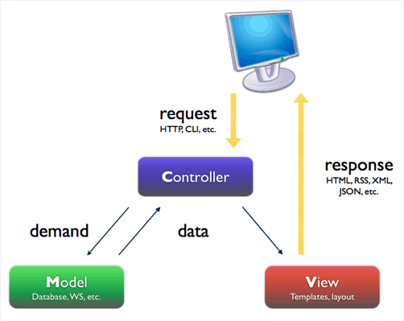

Figure 142: MVC Architecture

* Model: Functions that interact with the database or perform complex operations. In this architecture, model includes business logic and data access in one layer.
* View: The view displays the data and also takes input form user. It renders the model data into a form, such as graphics, buttons, and tables, and so on to display to the user.
* Controller: The controller handles all requests coming from the view or user interface. The data flows to whole application are controlled by controller.

### Discussion of Alternative Designs

N/A

### Description of System Interface

#### User Interfaces

UI should be simple, model and easy to use.

Support drag & drop easy for using Calendar Event.

#### Hardware Interfaces

The site should be deployed and available to a many devices can be use online.

* Server hardware: Support Windows hosting
* Client hardware: Can be desktop, laptop, smart phone, tablet,.. have internet connection

#### Software Interfaces

Run best on FireFox browser.

#### Communication Interfaces

The system using HTTP protocol to communicate between server and clients.

## Package Diagram

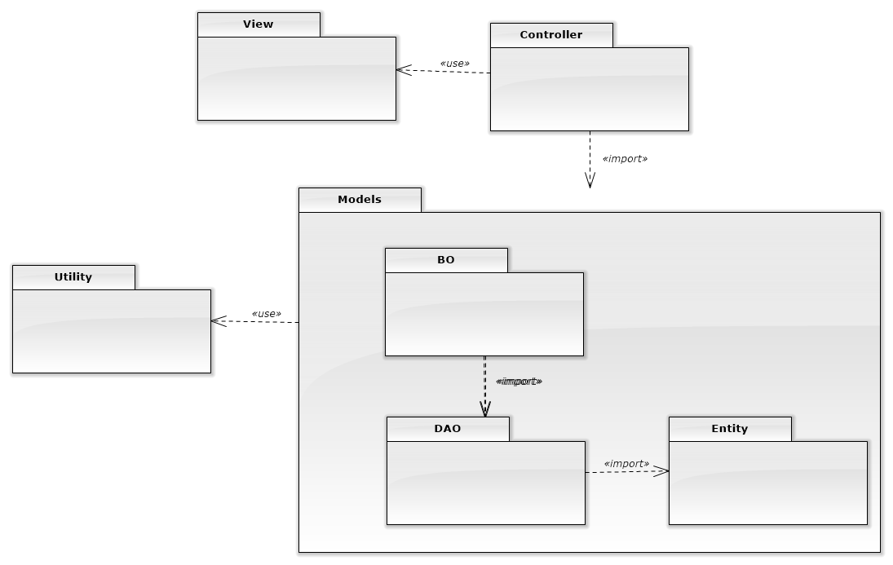

Figure 143: Package Diagram

## Detailed Description of Packages

### Data Transfer

#### Data Transfer Class Diagram

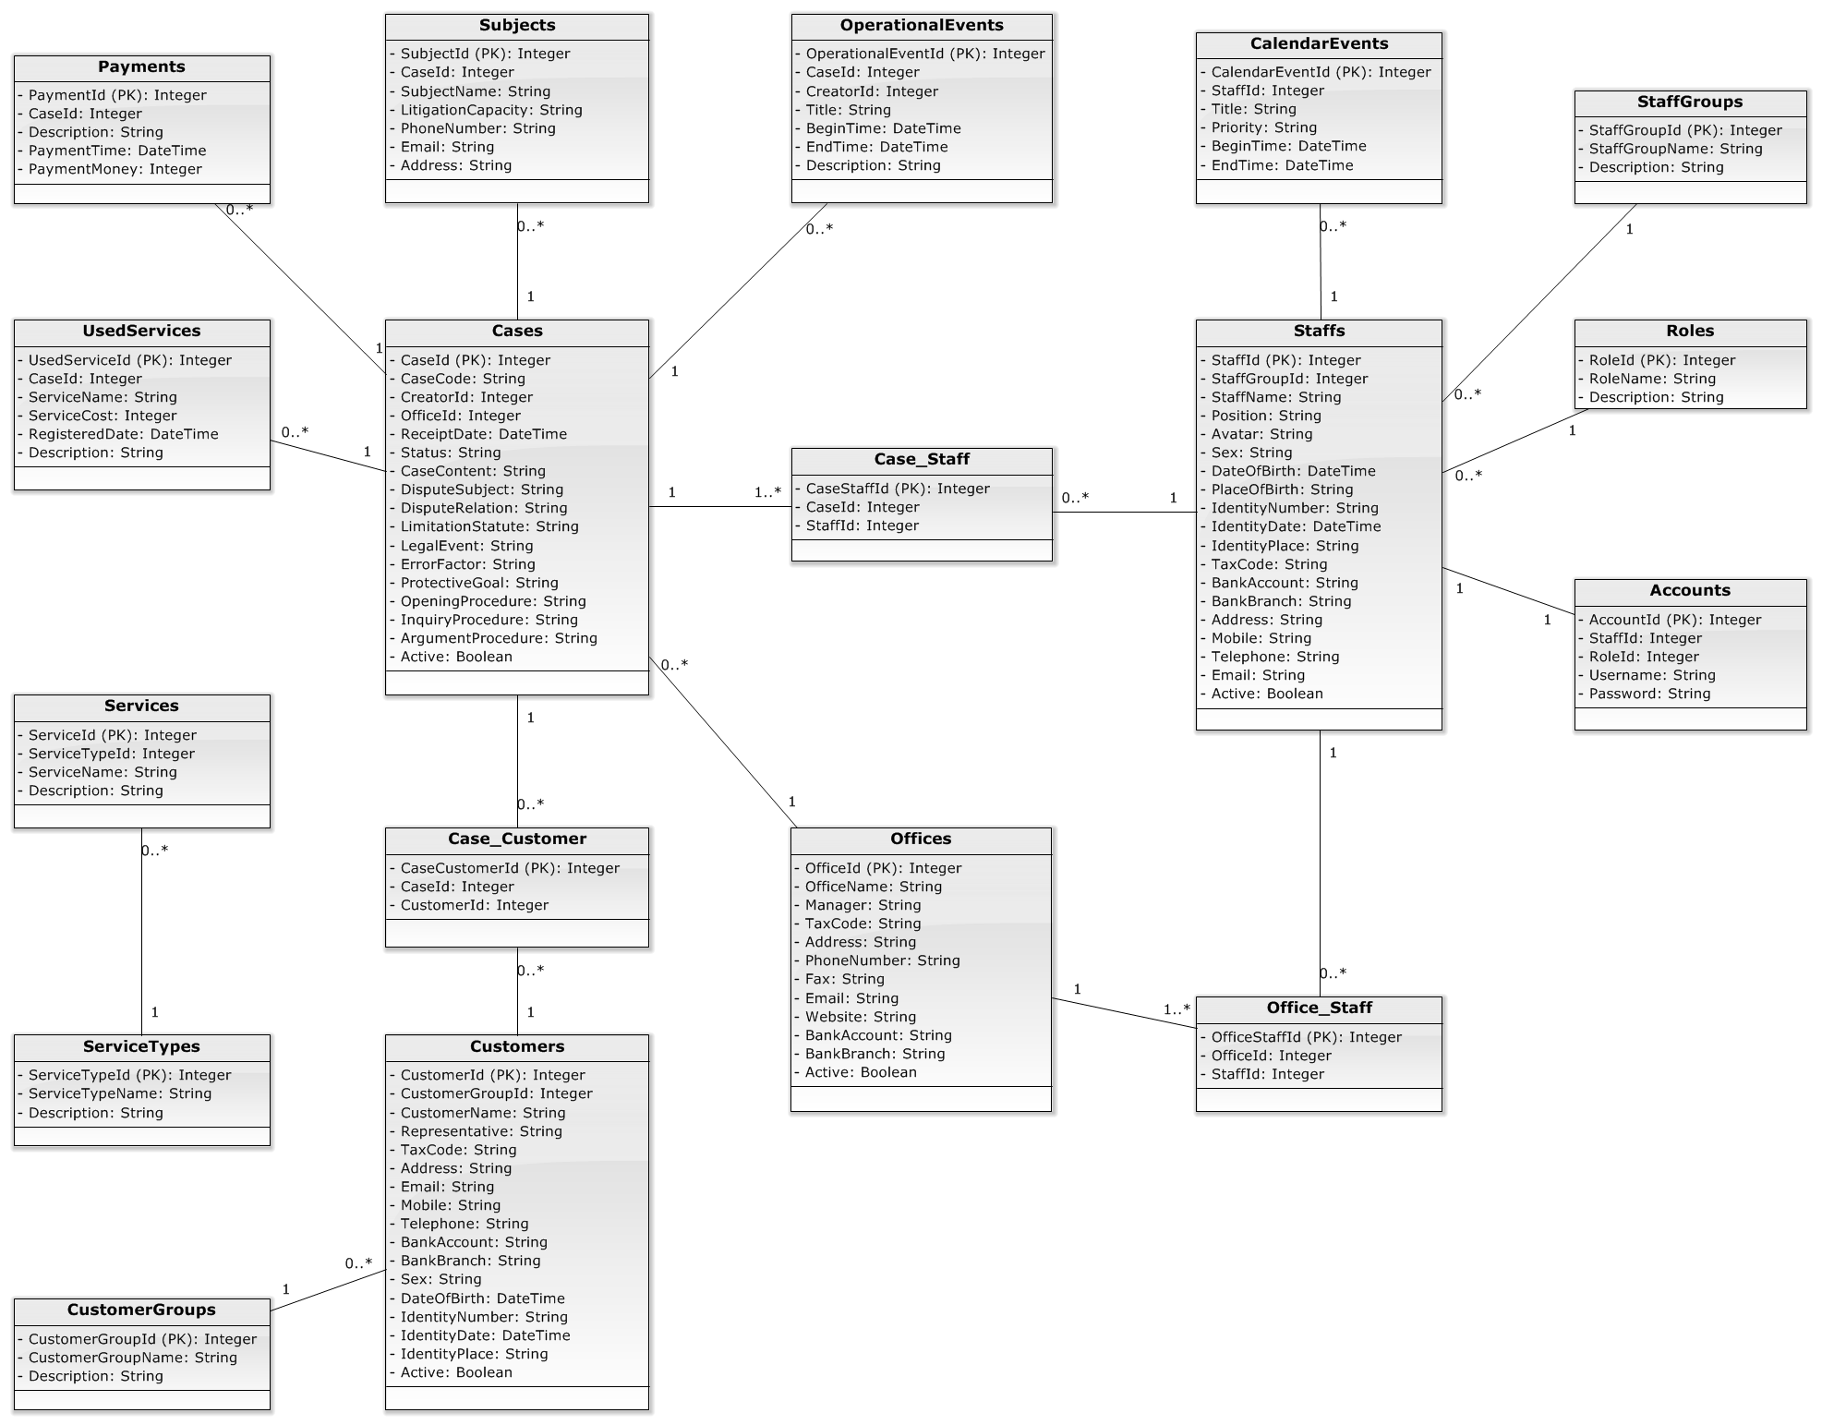

Figure 144: Data Transfer Class Diagram

#### Data Transfer Class Diagram Explanation

Reference to DVD: <root>/Documents/LFMS Project Document - Full Report.docx

### Controller

#### Controller Class Diagram

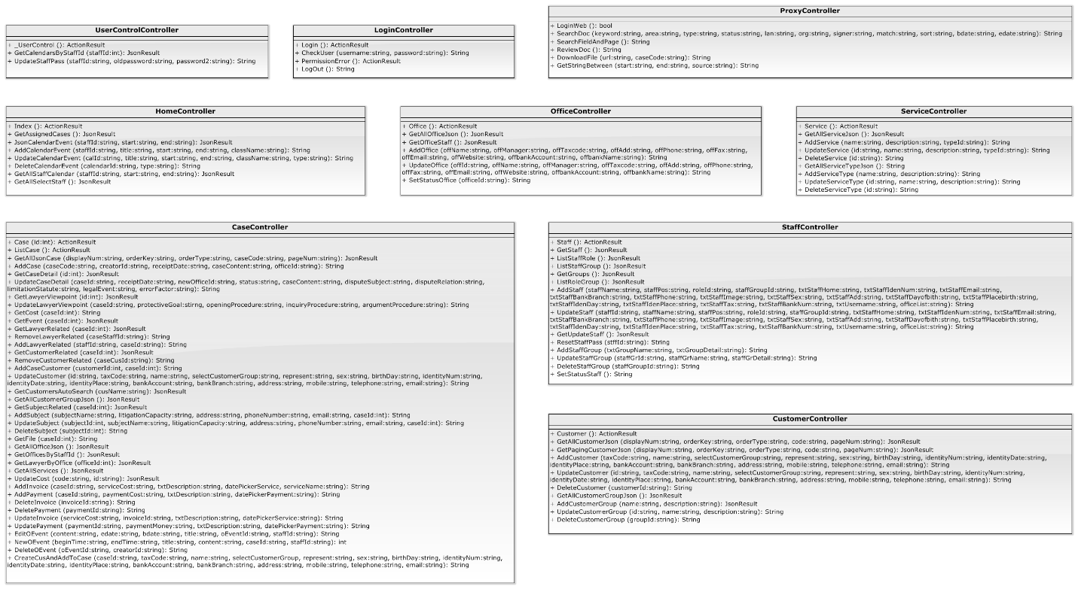

Figure 145: Controller Class Diagram

#### Controller Class Diagram Explanation

Reference to DVD: <root>/Documents/LFMS Project Document - Full Report.docx

### Business

#### Business Class Diagram

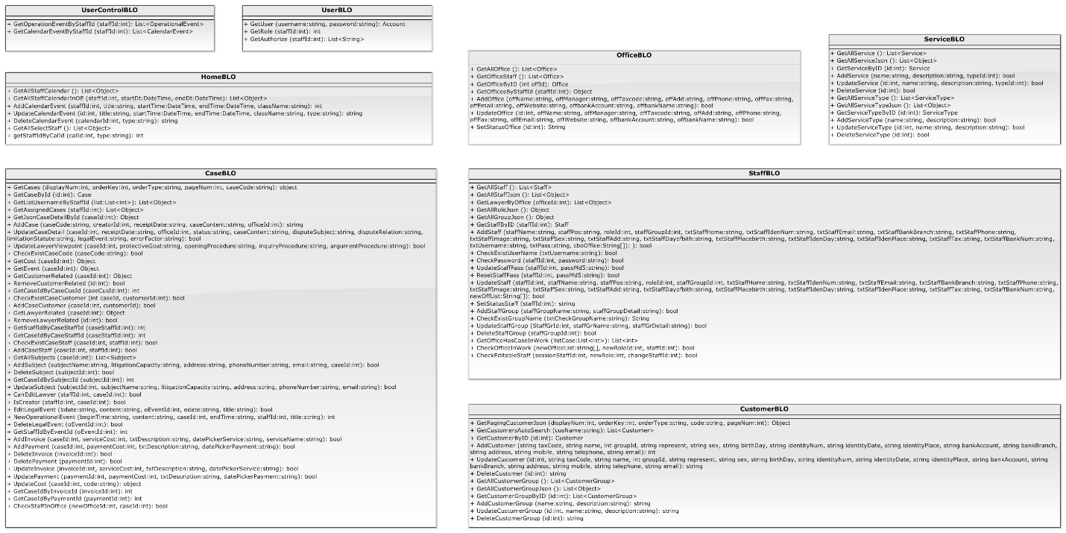

Figure 146: Business Class Diagram

#### Business Class Diagram Explanation

Reference to DVD: <root>/Documents/LFMS Project Document - Full Report.docx

### Data Access

#### Data Access Class Diagram

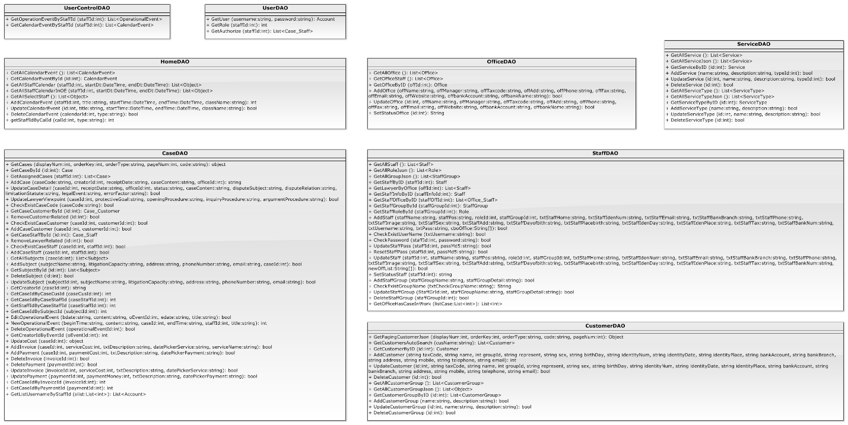

Figure 147: Data Access Class Diagram

#### Data Access Class Diagram Explanation

Reference to DVD: <root>/Documents/LFMS Project Document - Full Report.docx

## Sequence Diagram

### Login

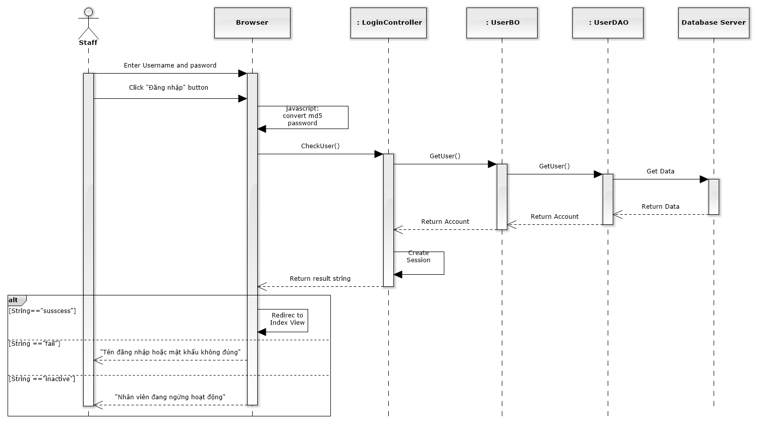

Figure 148: Login Sequence Diagram

### Change Password

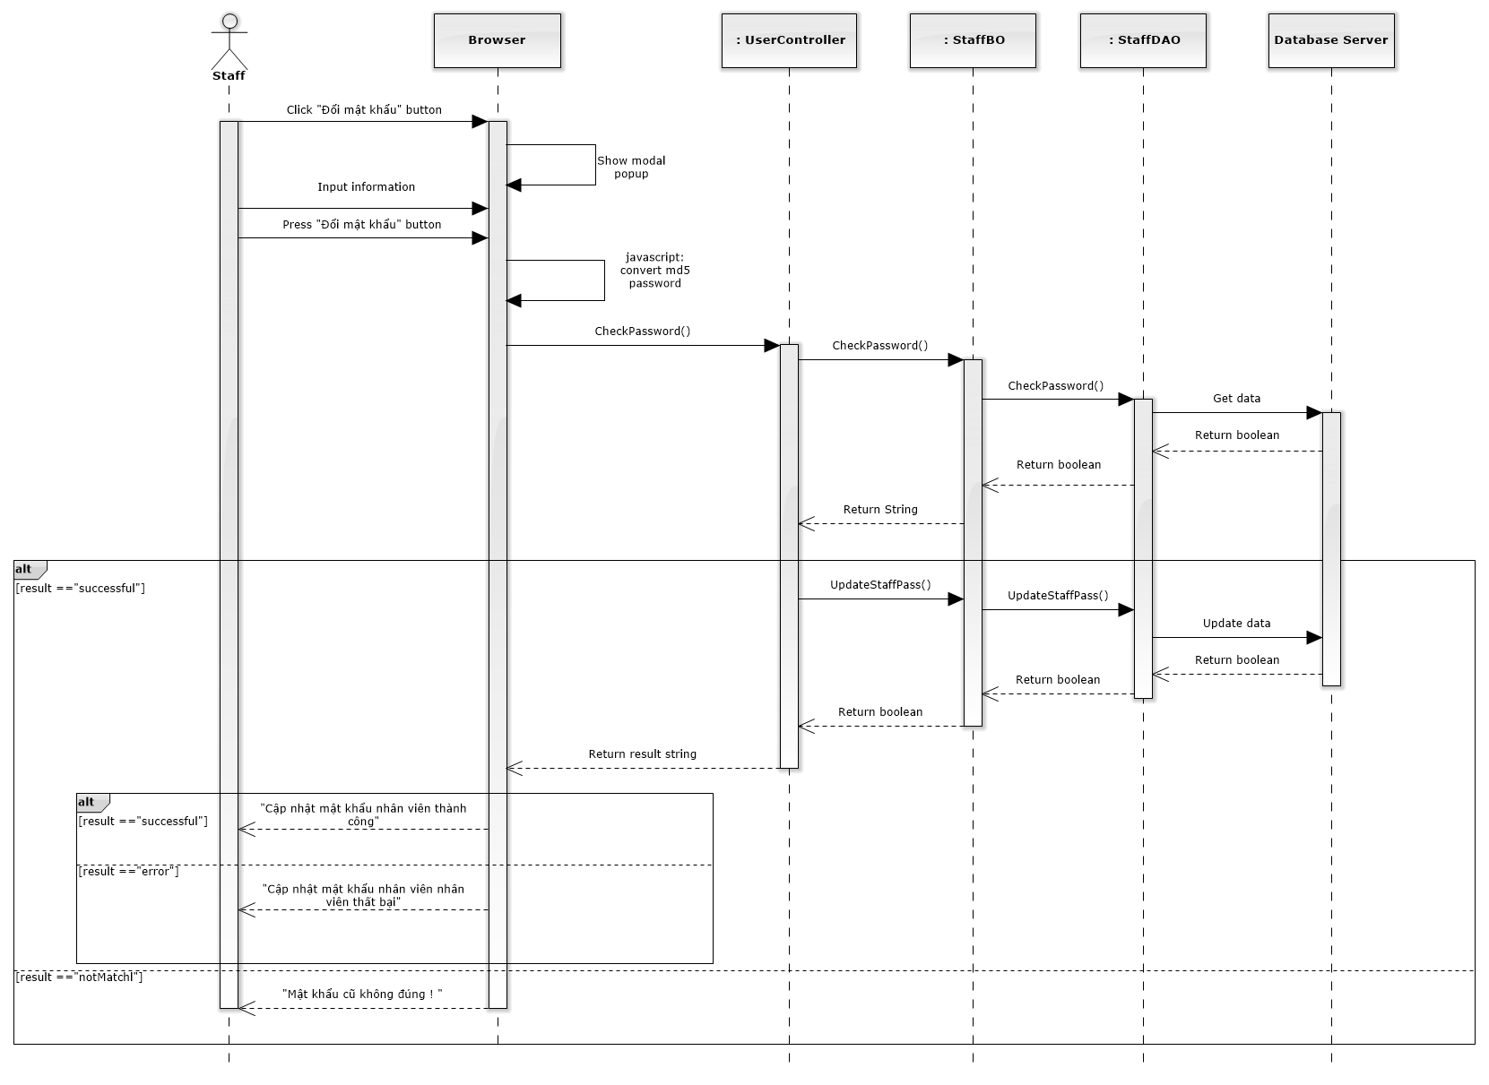

Figure 149: Change Password Sequence Diagram

### View Home

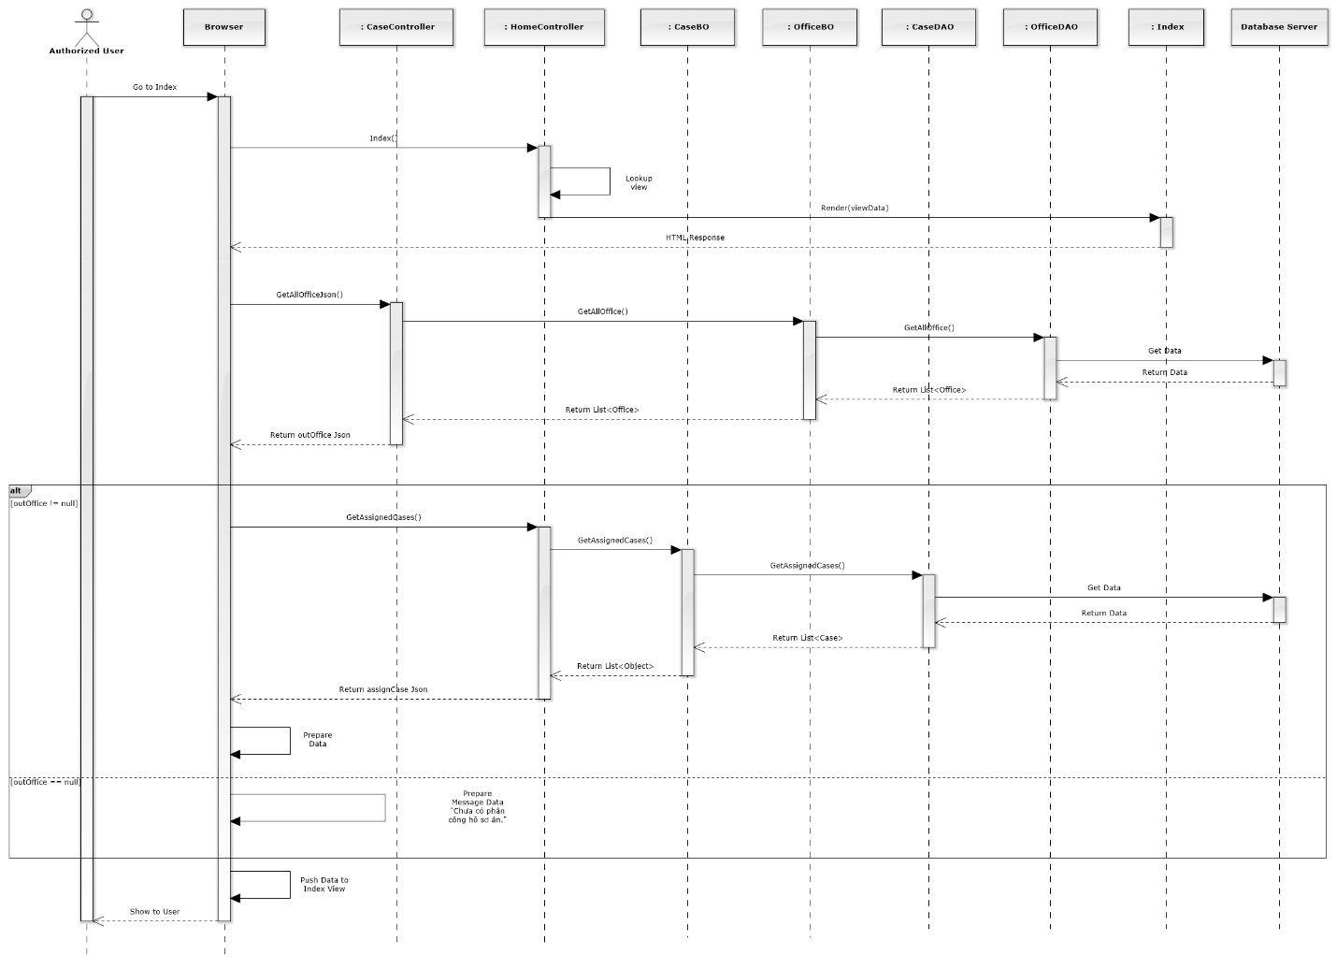

Figure 150: View Home Sequence Diagram

### Notify

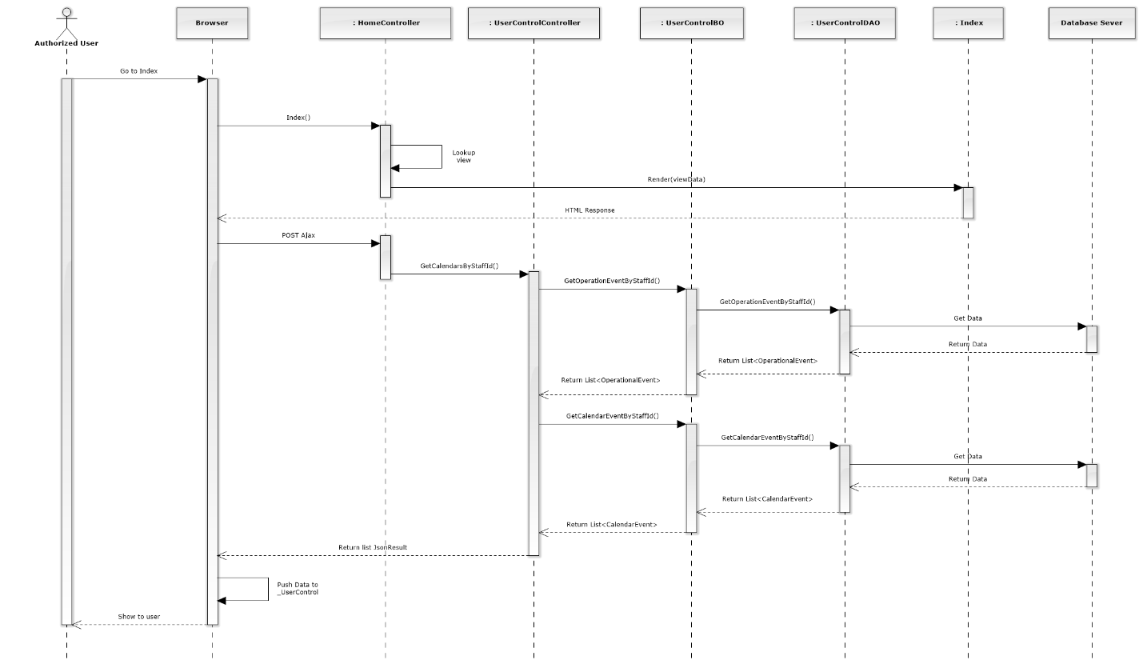

Figure 151: Notify Sequence Diagram

### Manage Calendar Event

#### List Calendar Events

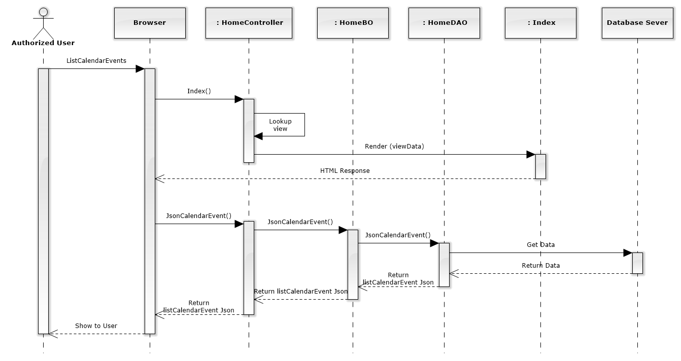

Figure 152: List Calendar Events Sequence Diagram

#### Add New Calendar Event

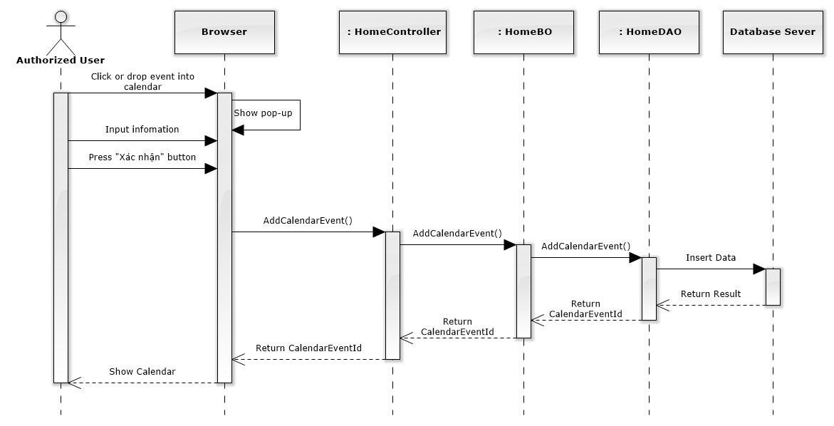

Figure 153: Add New Calendar Event Sequence Diagram

#### Edit Calendar Event

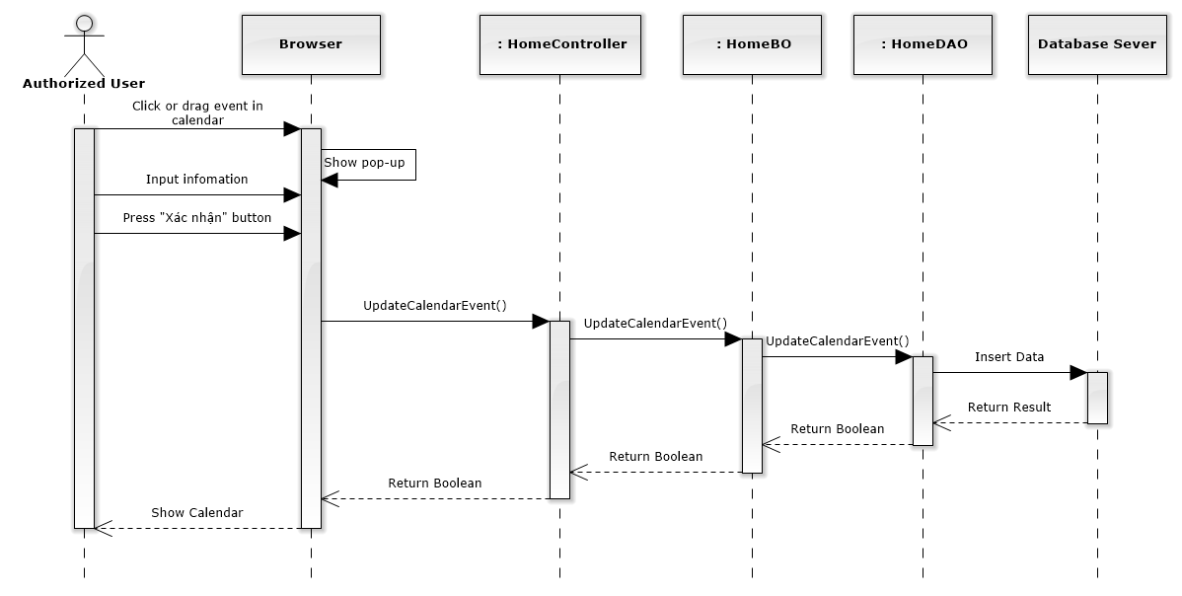

Figure 154: Edit Calendar Event Sequence Diagram

#### Delete Calendar Event

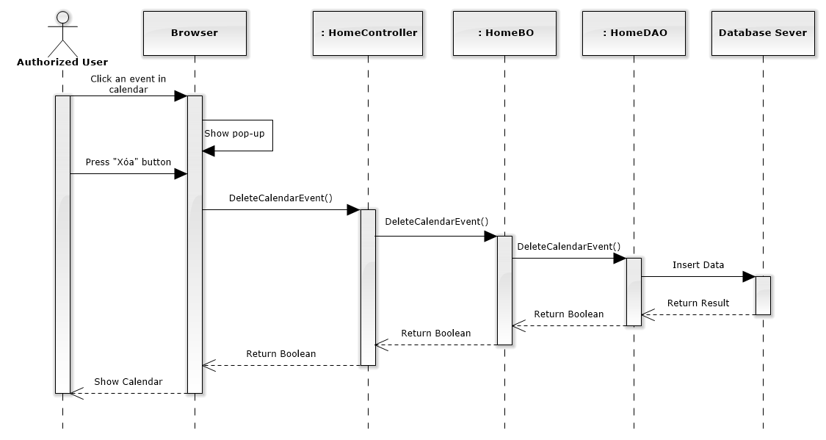

Figure 155: Delete Calendar Event Sequence Diagram

### Manage Case

#### List All Cases

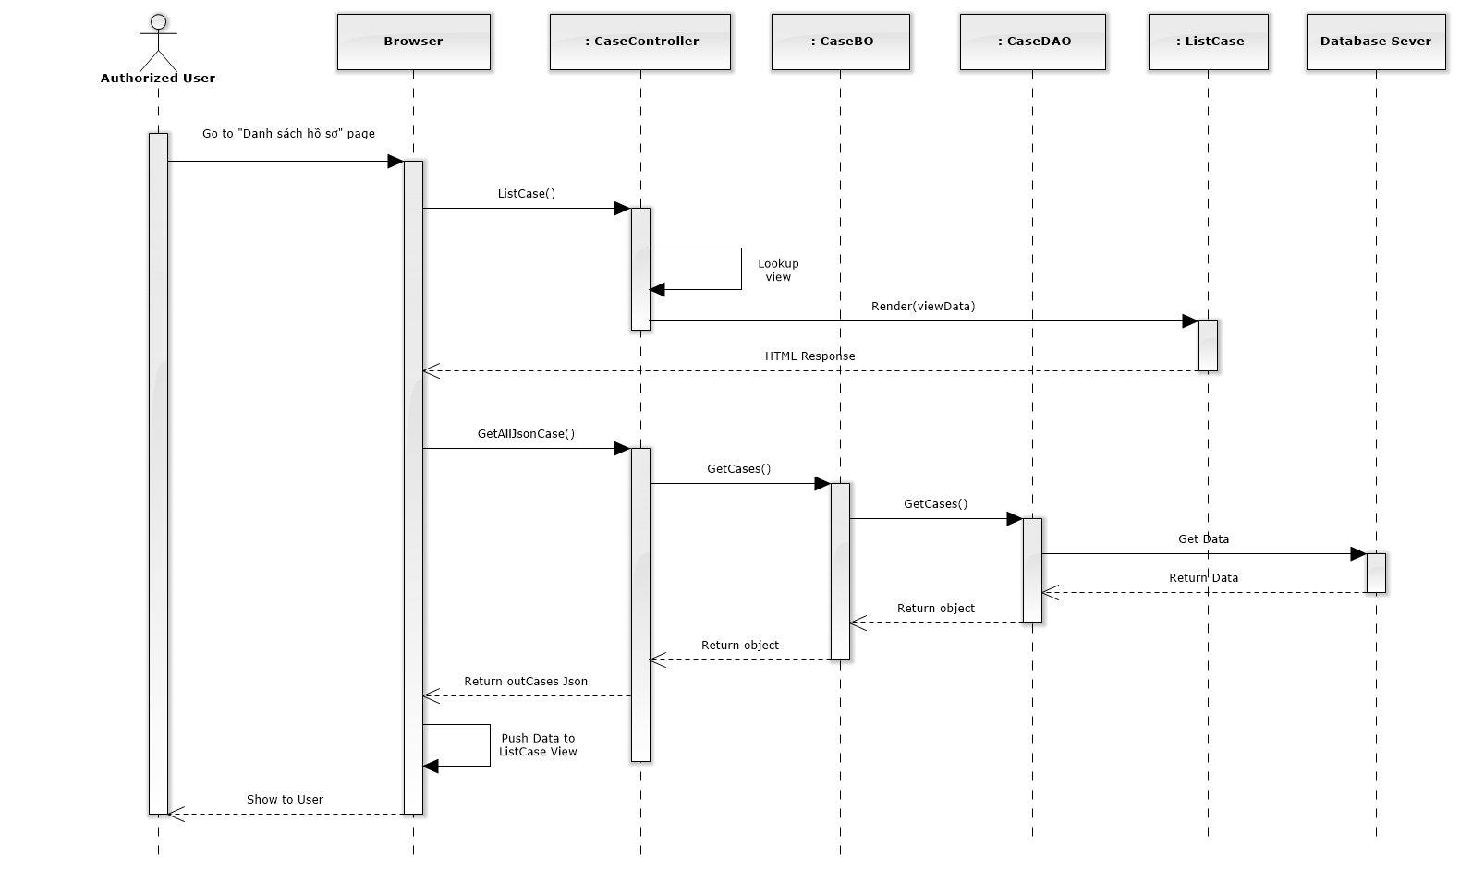

Figure 156: List All Cases Sequence Diagram

#### Add New Case

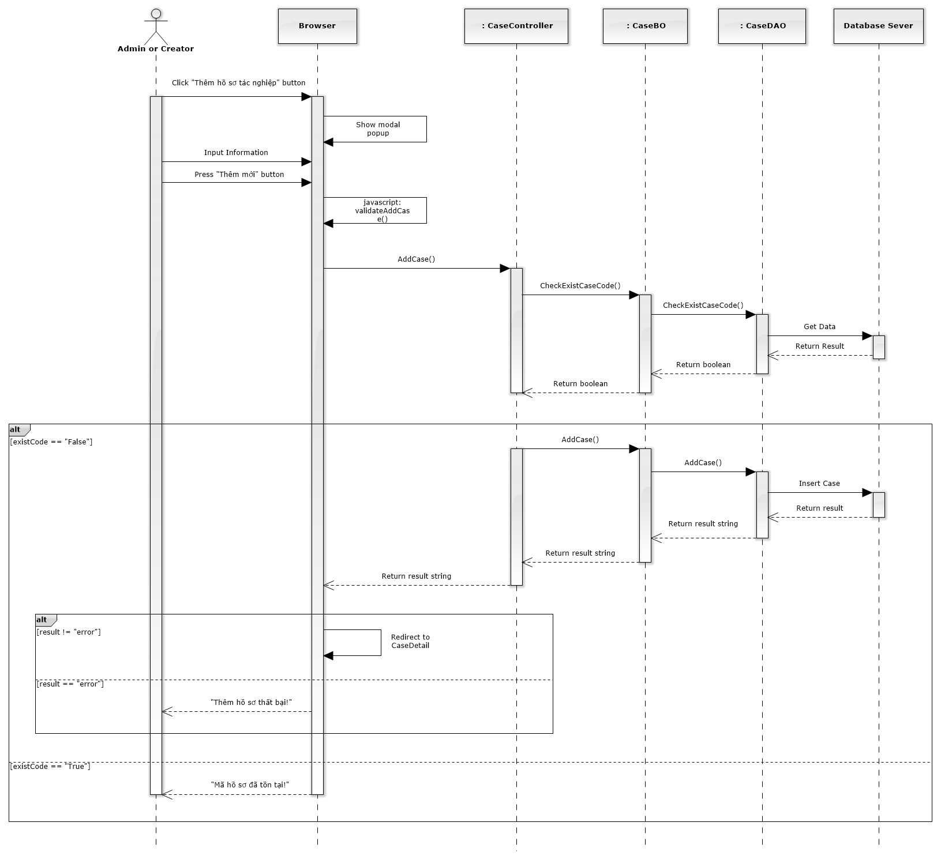

Figure 157: Add New Case Sequence Diagram

#### Search Case

Reference to DVD: <root>/Documents/LFMS Project Document - Full Report.docx

#### Manage Case Detail

##### Manage Case Info

Reference to DVD: <root>/Documents/LFMS Project Document - Full Report.docx

##### Manage Operation Event

###### List Operation Events

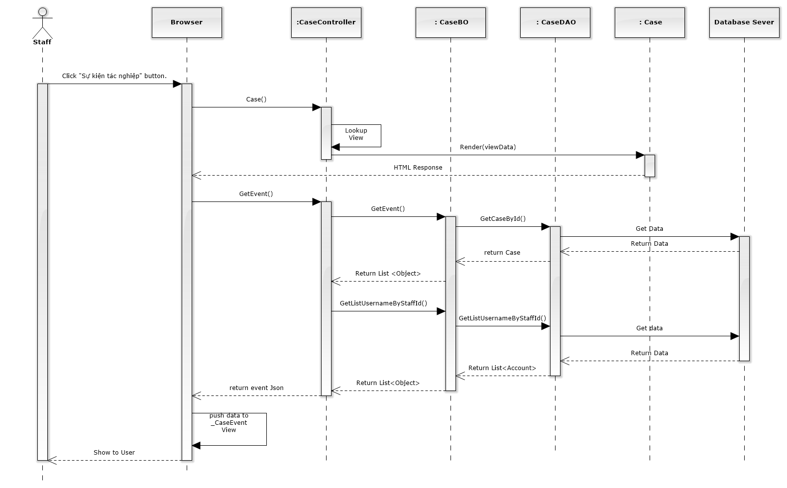

Figure 158: List Operation Events Sequence Diagram

###### Add New Operation Event

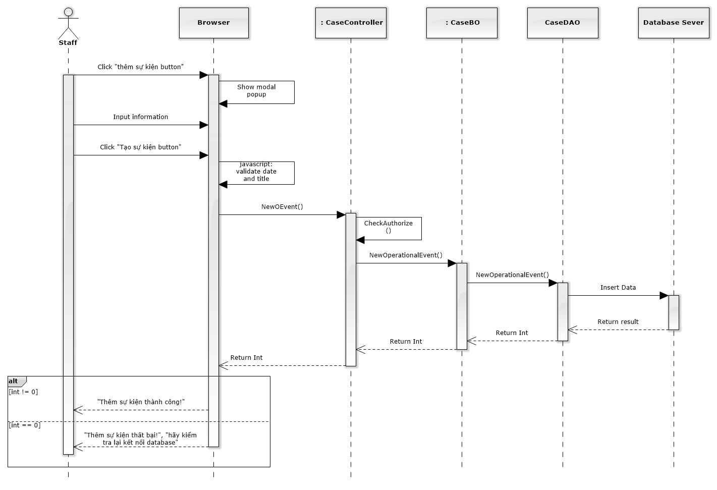

Figure 159: Add New Operation Event Sequence Diagram

###### Edit Operation Event

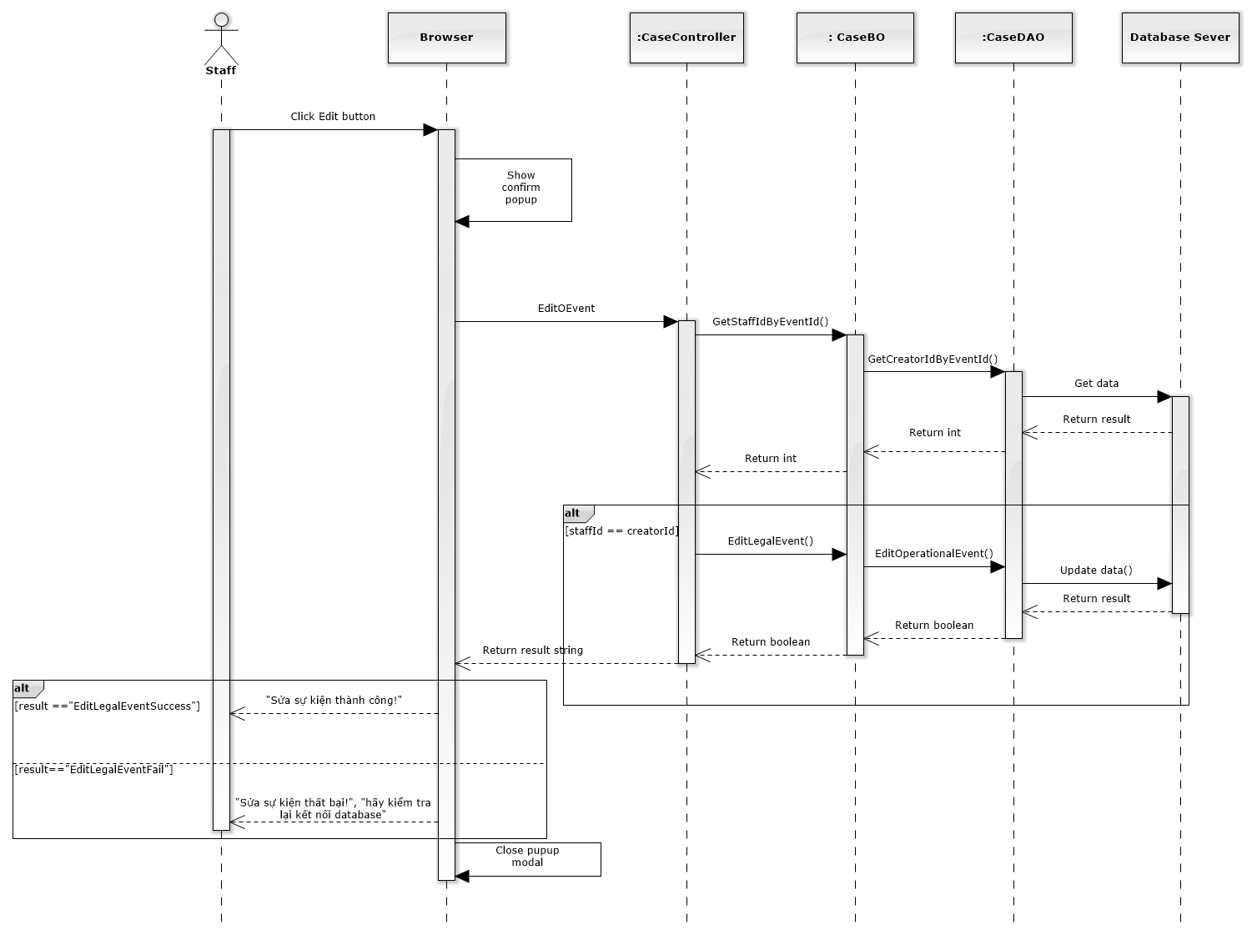

Figure 160: Edit Operation Event Sequence Diagram

###### Delete Operation Event

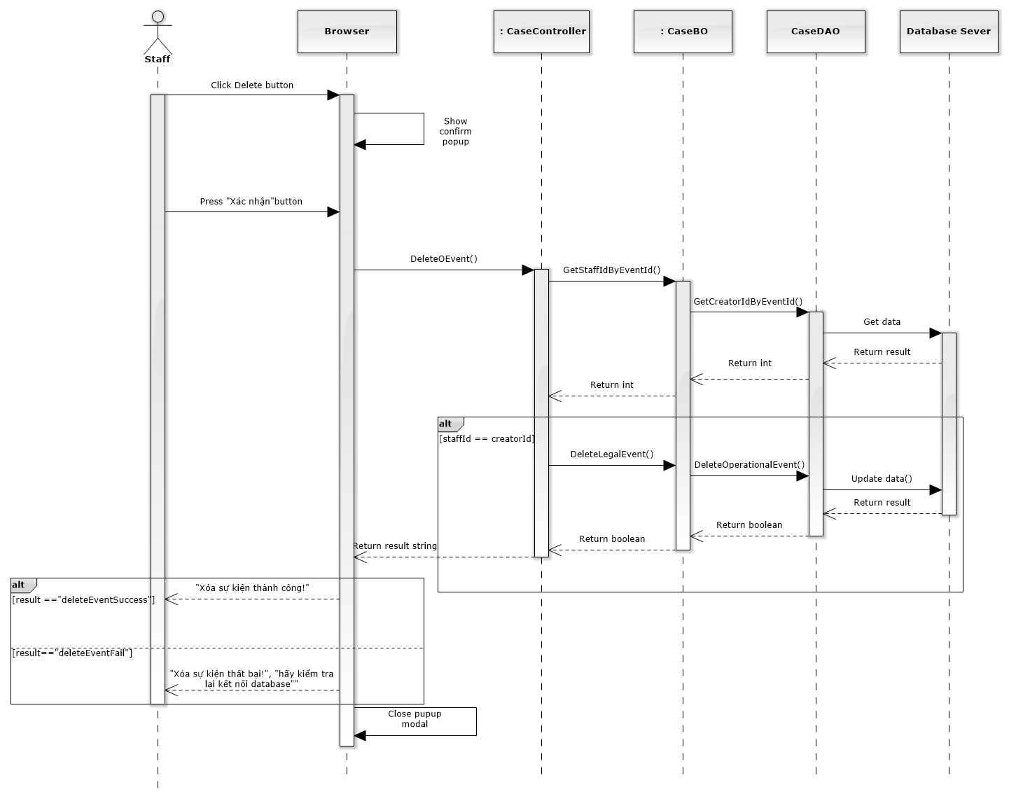

Figure 161: Delete Operation Event Sequence Diagram

##### Manage Lawyer Related

Reference to DVD: <root>/Documents/LFMS Project Document - Full Report.docx

##### Manage Customer Related

Reference to DVD: <root>/Documents/LFMS Project Document - Full Report.docx

##### Manage Subject Related

Reference to DVD: <root>/Documents/LFMS Project Document - Full Report.docx

##### Manage Document Related

Reference to DVD: <root>/Documents/LFMS Project Document - Full Report.docx

##### Manage Used Service

Reference to DVD: <root>/Documents/LFMS Project Document - Full Report.docx

##### Manage Payment

Reference to DVD: <root>/Documents/LFMS Project Document - Full Report.docx

##### Integrate Thư Viện Pháp Luật

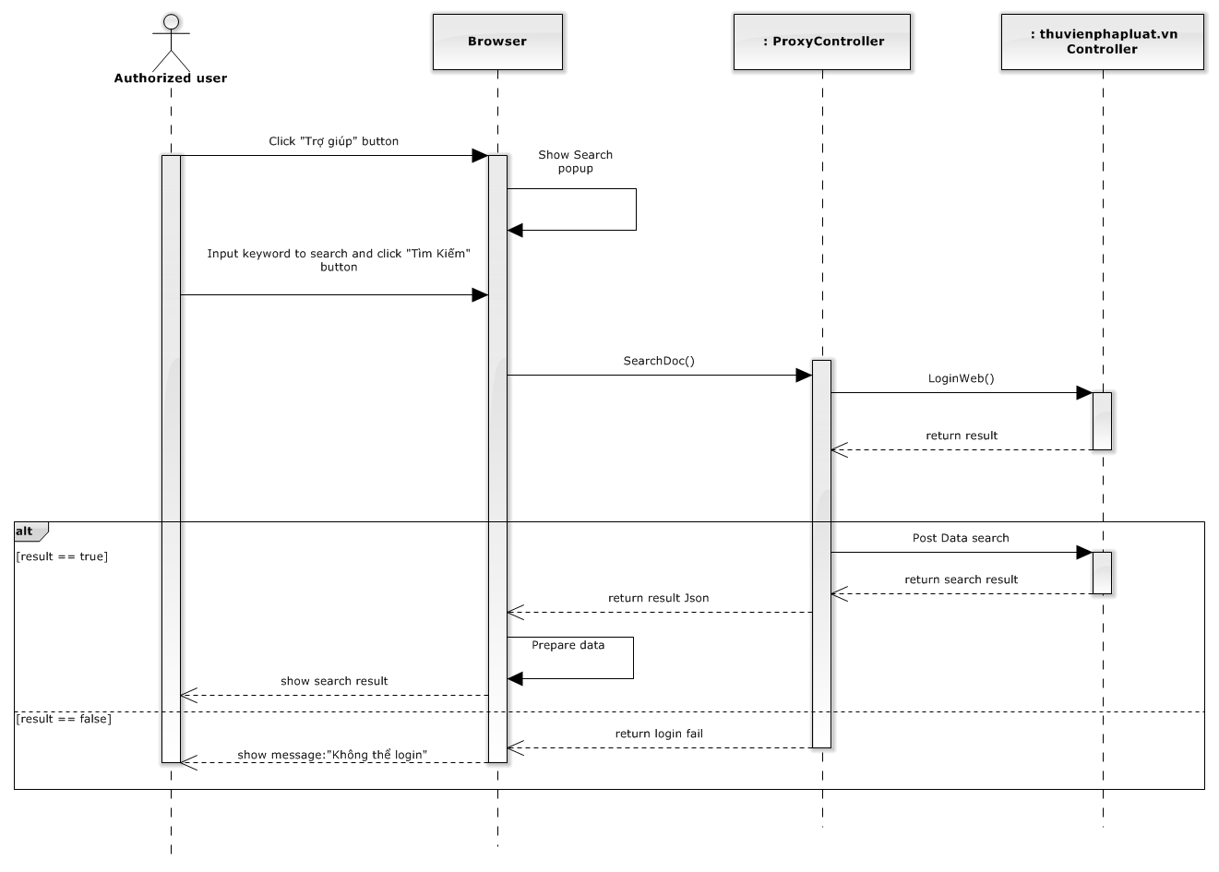

Figure 162: Integrate Thư Viện Pháp Luật Sequence Diagram

### Manage Customer Group

Reference to DVD: <root>/Documents/LFMS Project Document - Full Report.docx

### Manage Customer

#### List Customers

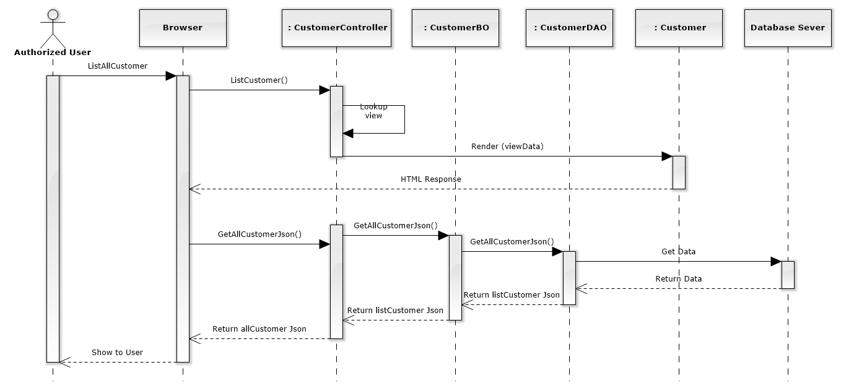

Figure 163: List Customers Sequence Diagram

#### Add New Customer

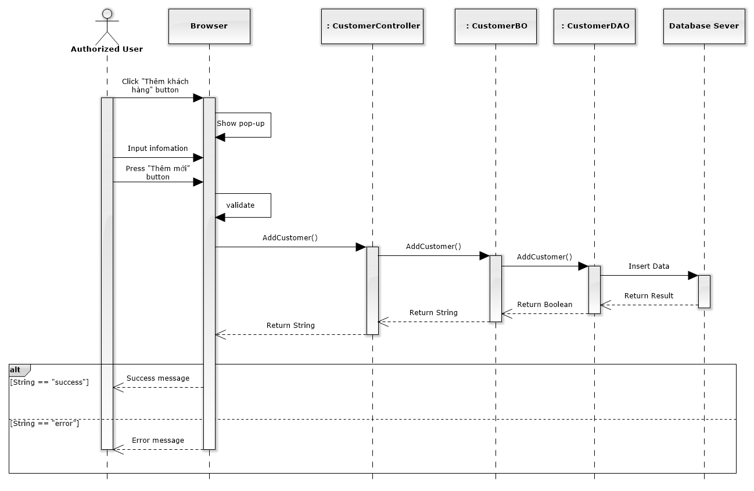

Figure 164: Add New Customer Sequence Diagram

#### Edit Customer

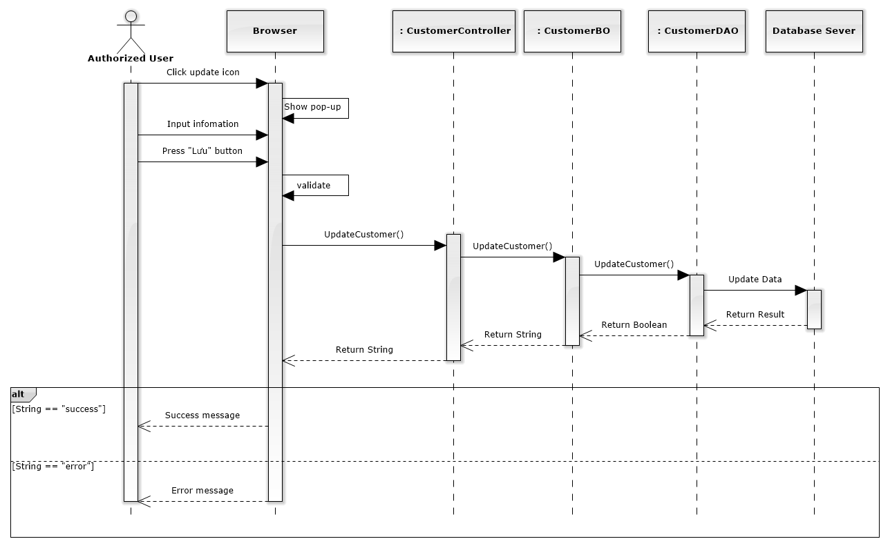

Figure 165: Edit Customer Sequence Diagram

#### Delete Customer

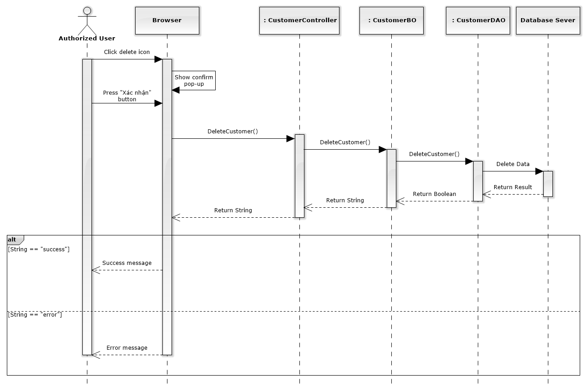

Figure 166: Delete Customer Sequence Diagram

### Manage Staff Group

Reference to DVD: <root>/Documents/LFMS Project Document - Full Report.docx

### Manage Staff

#### List Staffs

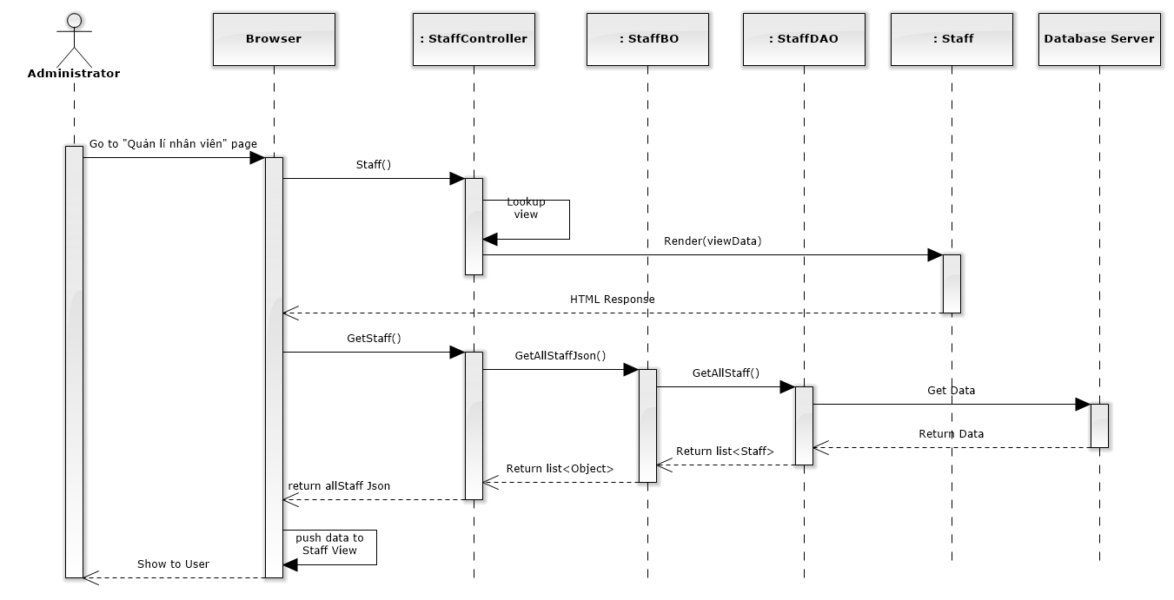

Figure 167: List Staffs Sequence Diagram

#### Add New Staff

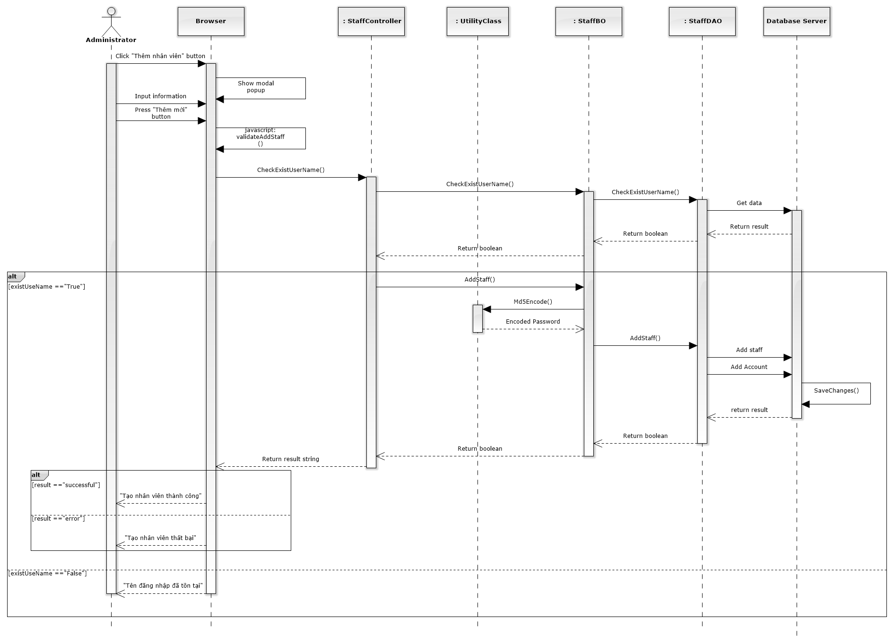

Figure 168: Add New Staff Sequence Diagram

#### Edit Staff

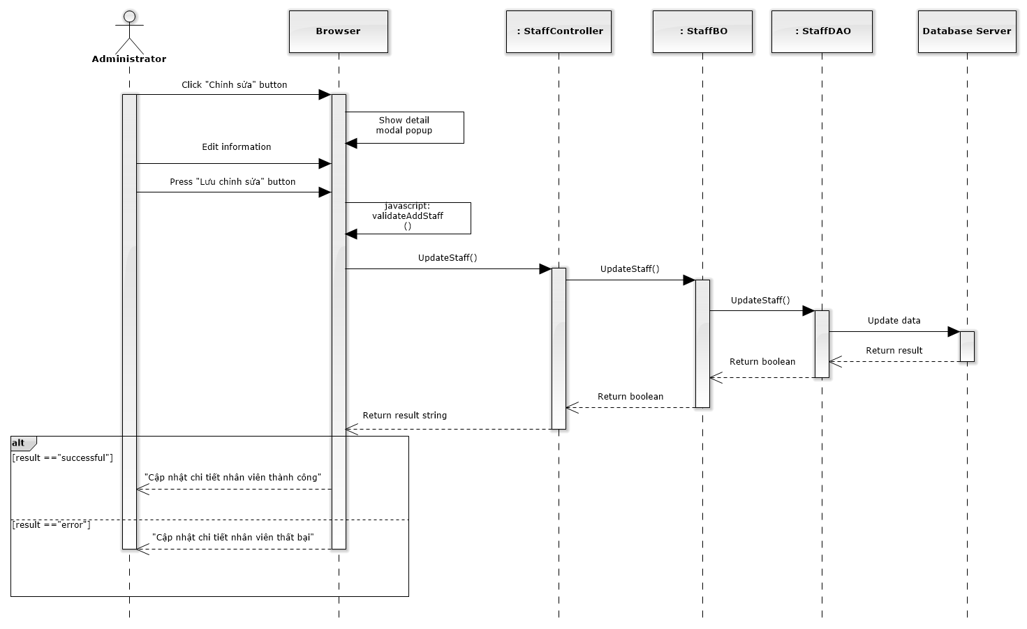

Figure 169: Edit Staff Sequence Diagram

#### Deactivate / Activate Staff

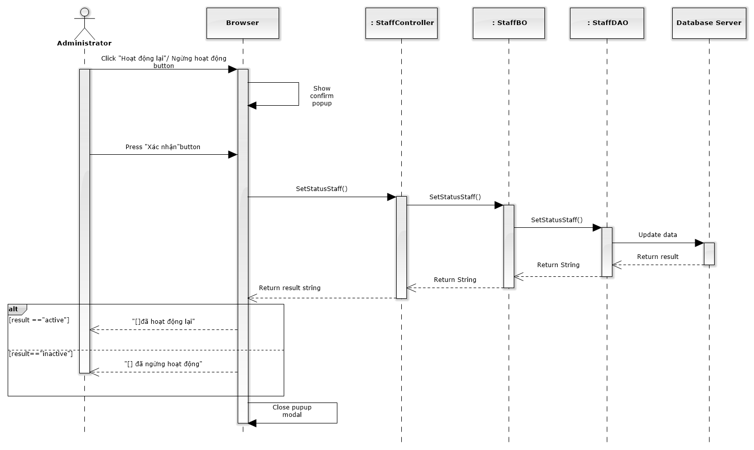

Figure 170: Deactivate / Activate Staff Sequence Diagram

#### Reset Password

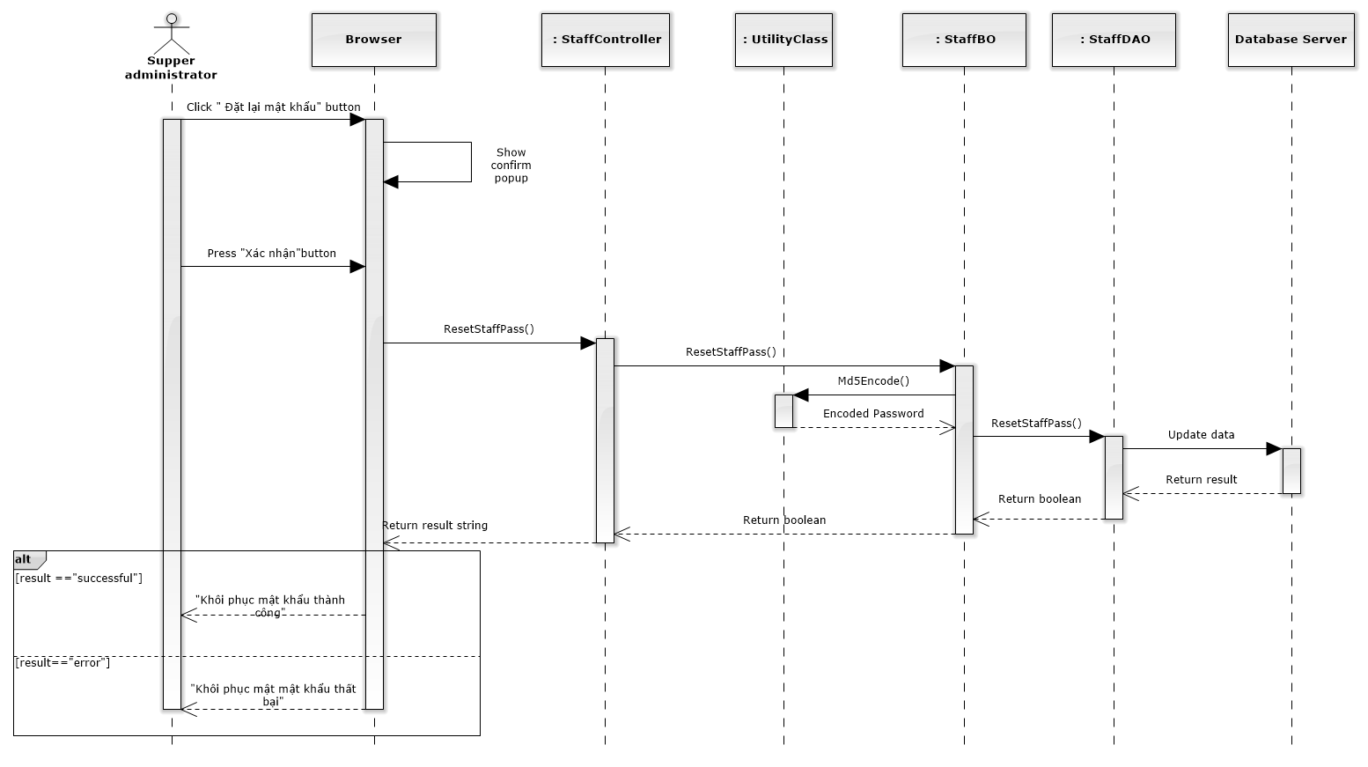

Figure 171: Reset Password Sequence Diagram

### Manage Service Type

Reference to DVD: <root>/Documents/LFMS Project Document - Full Report.docx

### Manage Service

#### List Services

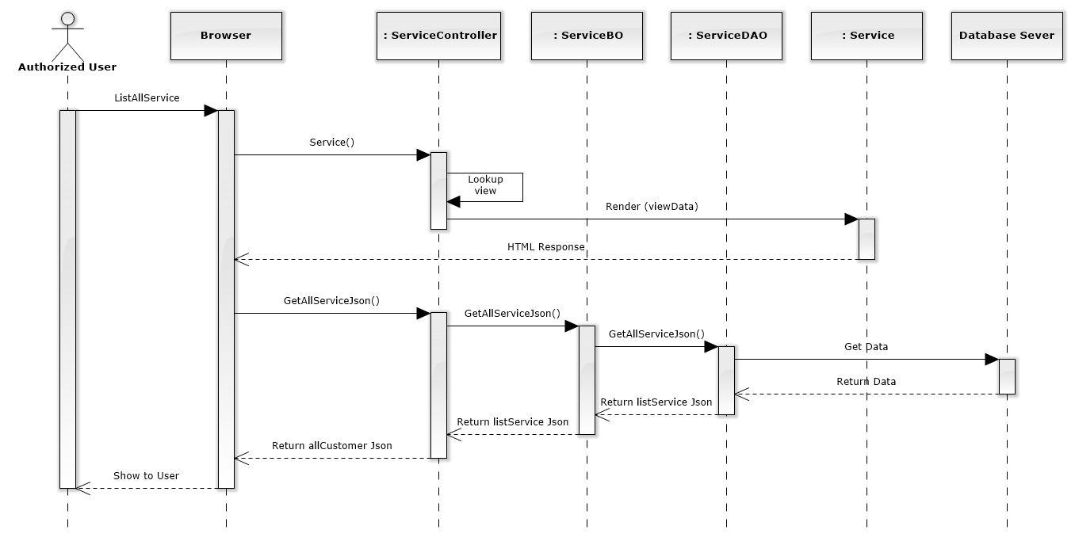

Figure 172: List Services Sequence Diagram

#### Add New Service

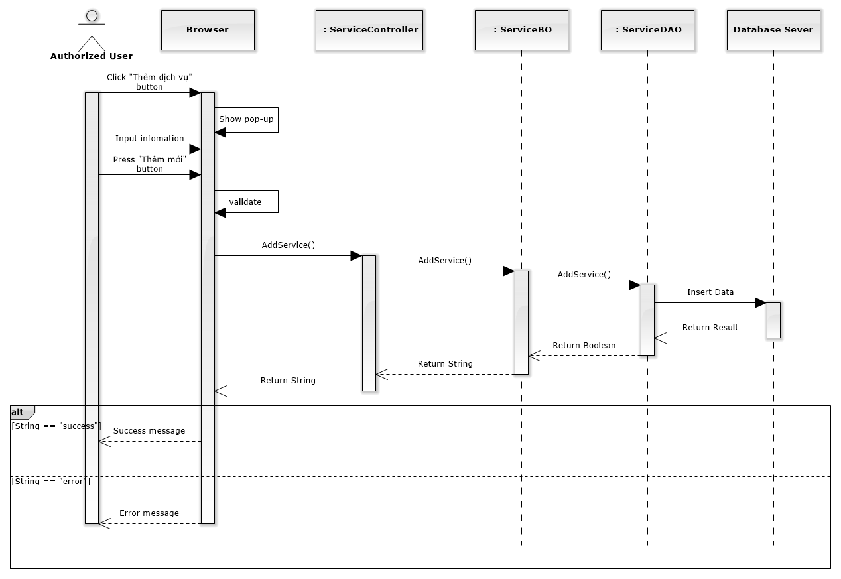

Figure 173: Add New Service Sequence Diagram

#### Edit Service

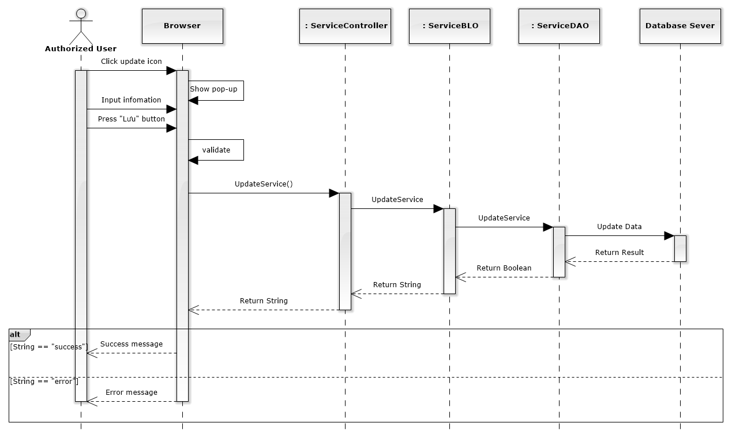

Figure 174: Edit Service Sequence Diagram

#### Delete Service

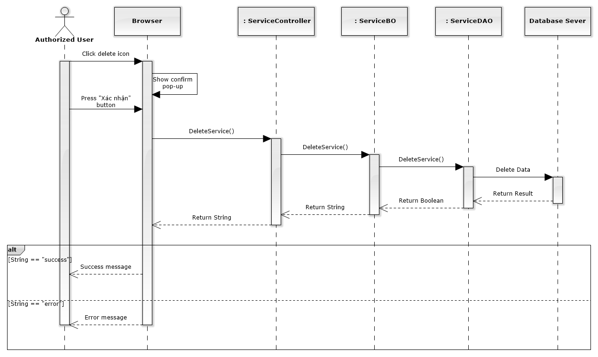

Figure 175: Delete Service Sequence Diagram

### Manage Office

#### List Offices

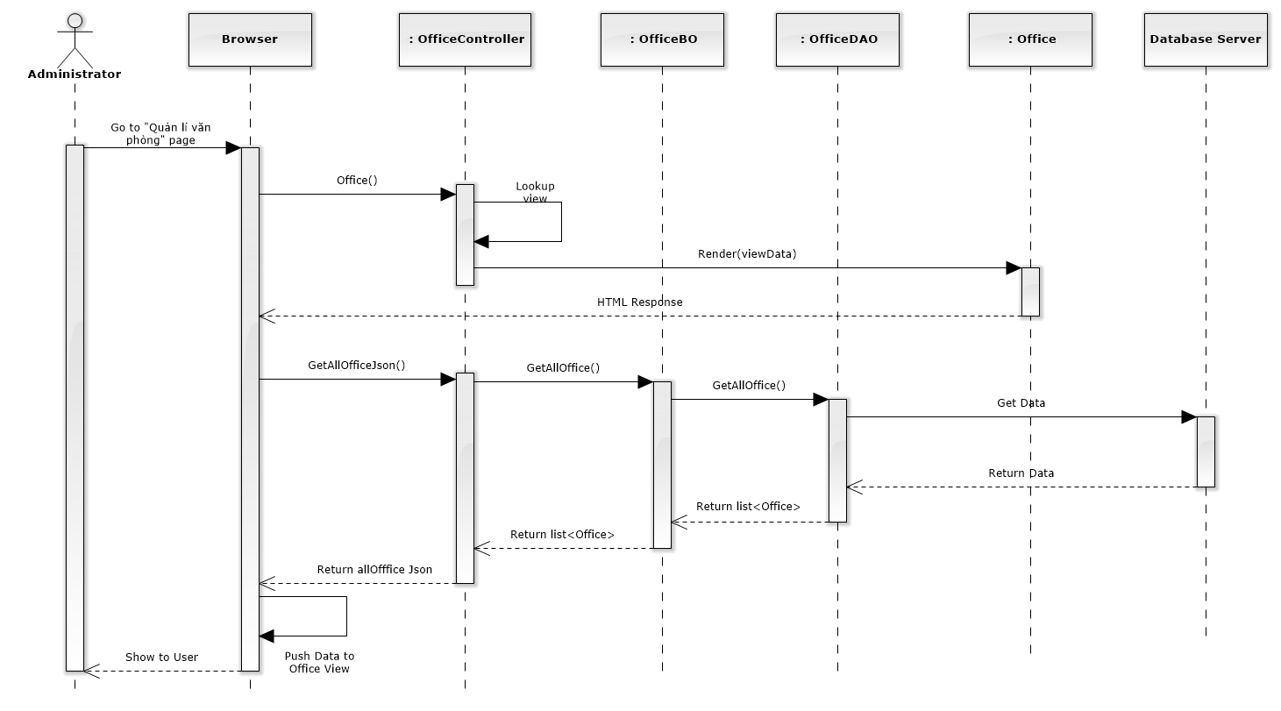

Figure 176: List Offices Sequence Diagram

#### Add New Office

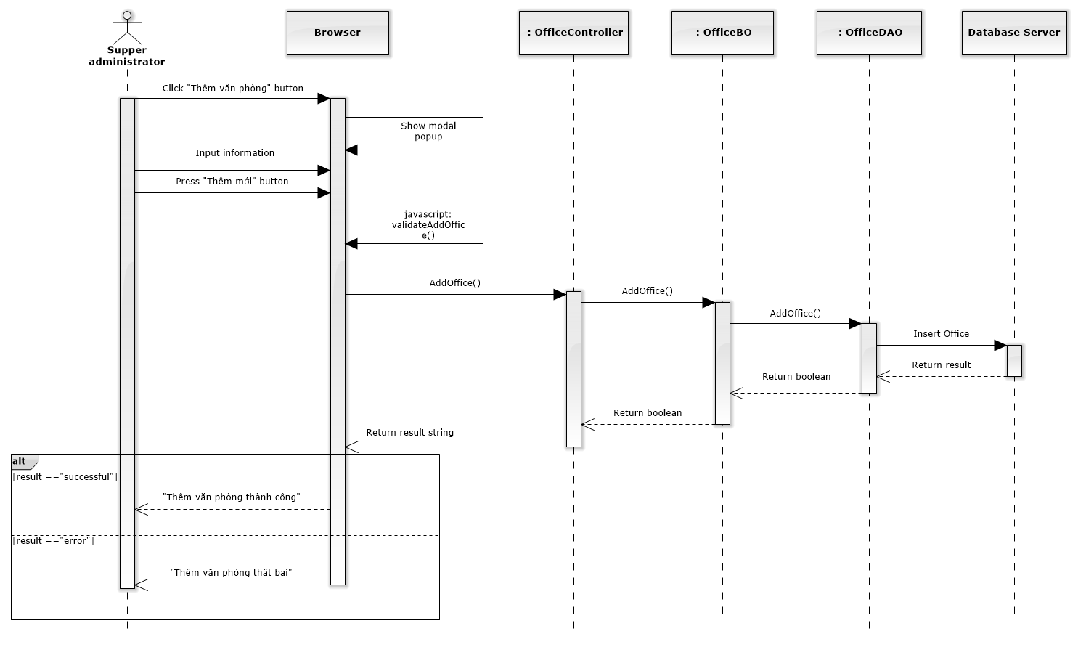

Figure 177: Add New Office Sequence Diagram

#### Edit Office

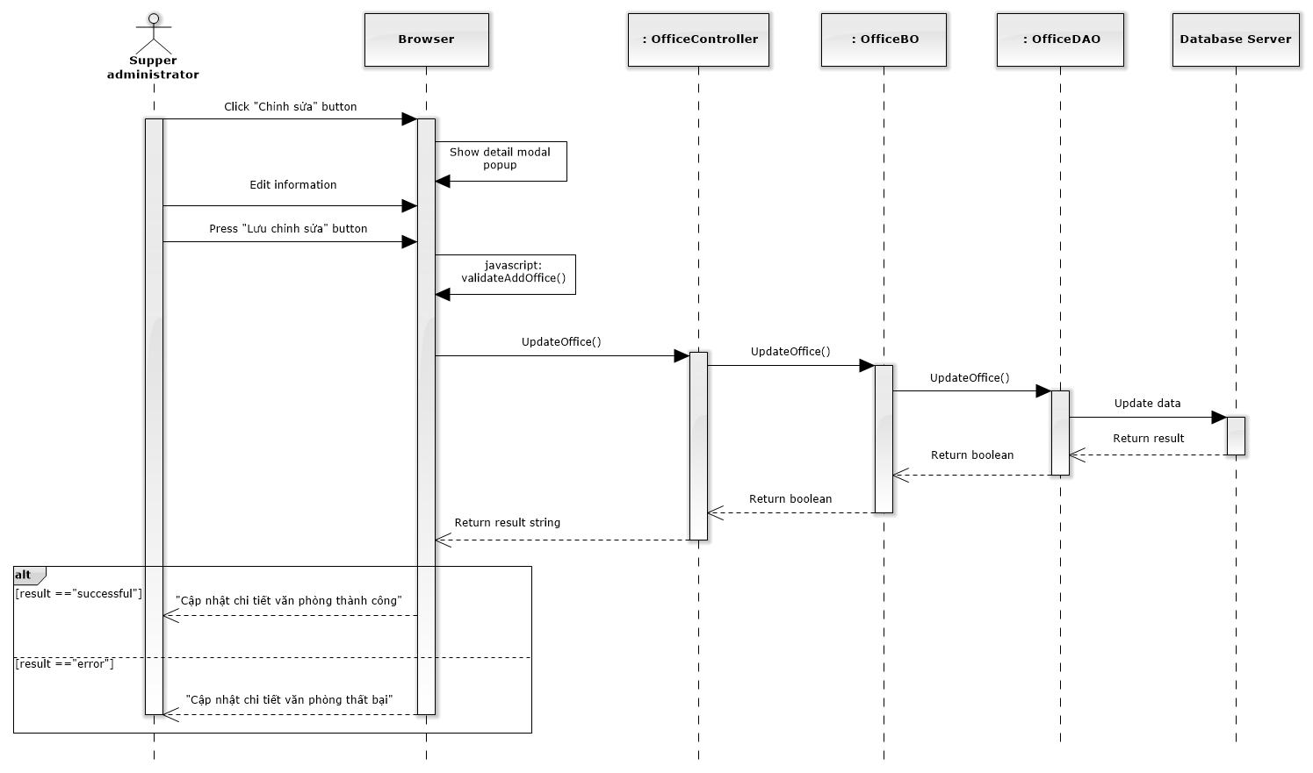

Figure 178: Edit Office Sequence Diagram

#### Deactivate / Activate Office

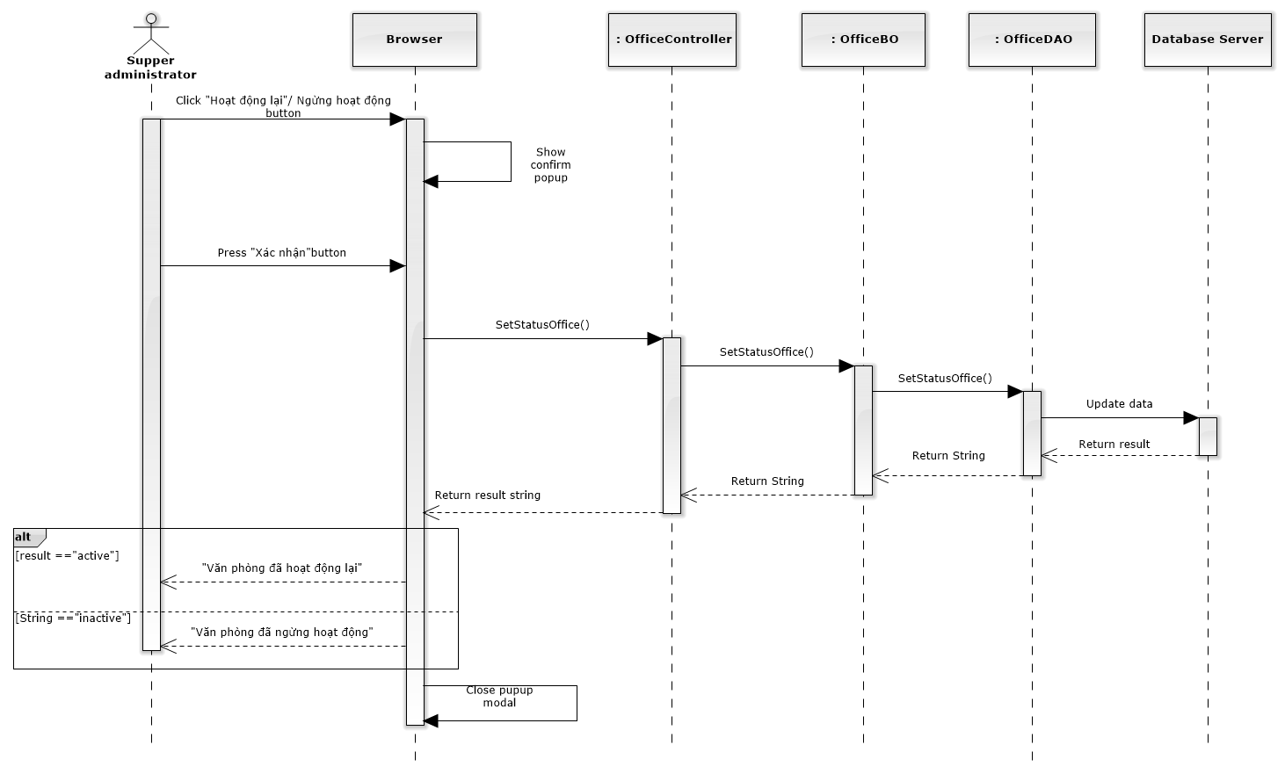

Figure 179: Deactivate / Activate Office Sequence Diagram

### Statistic

##### Office Statistic

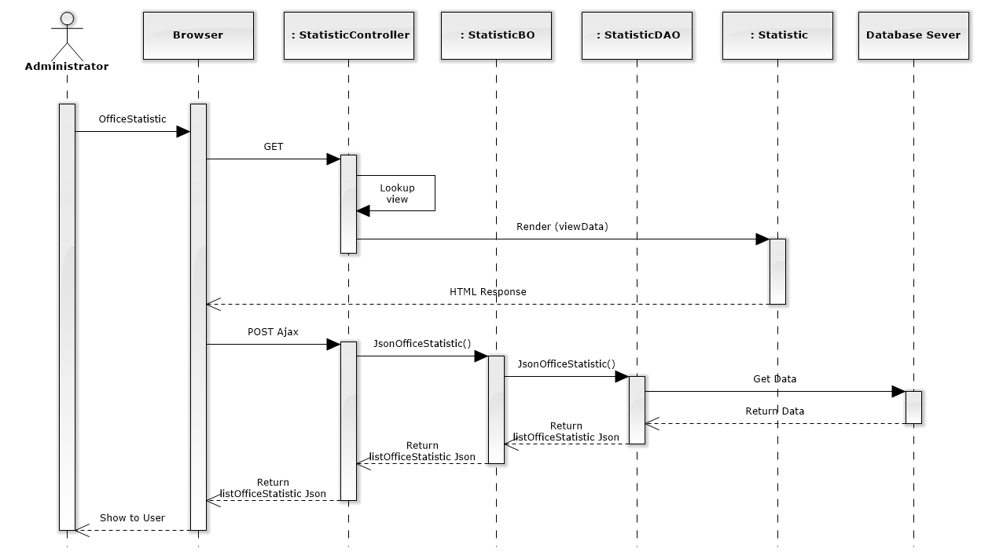

Figure 209: Office Statistic Sequence Diagram

##### Staff Statistic

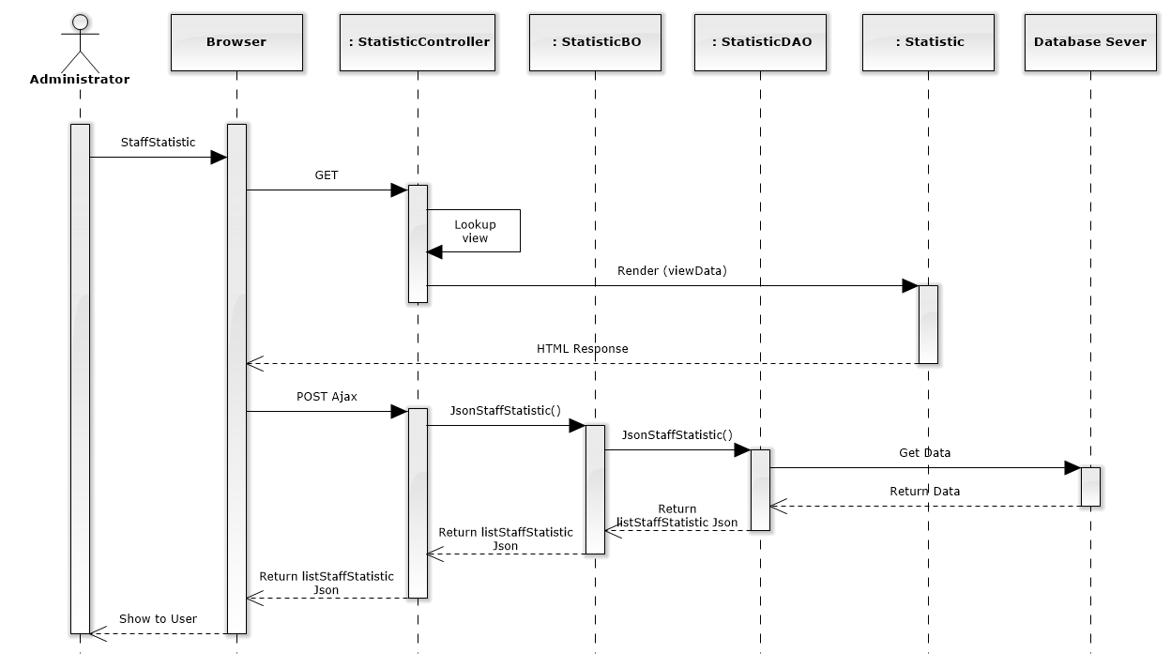

Figure 210: Staff Statistic Sequence Diagram

##### Revenue Statistic

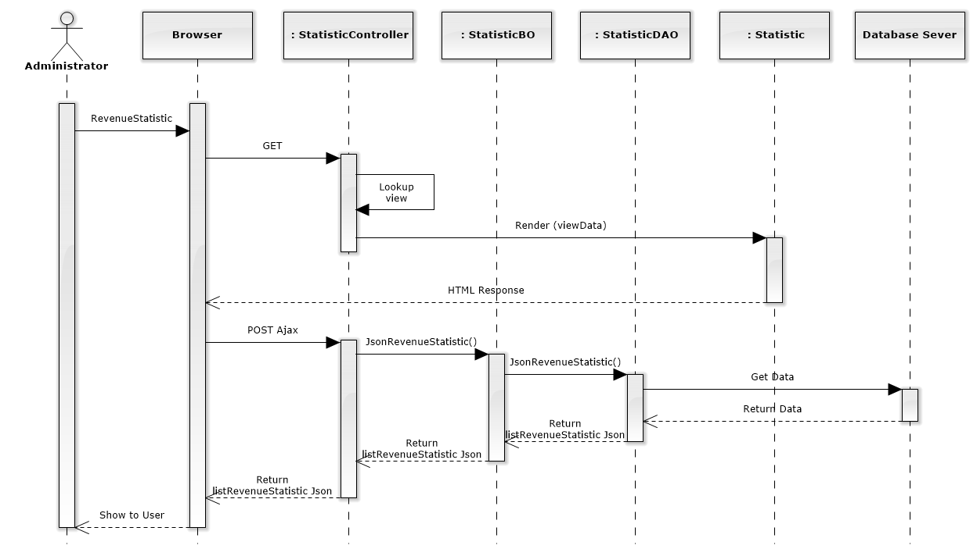

Figure 211: Revenue Statistic Sequence Diagram

### OtherCost

## User Interface Design

### Home

#### Home Screen Image

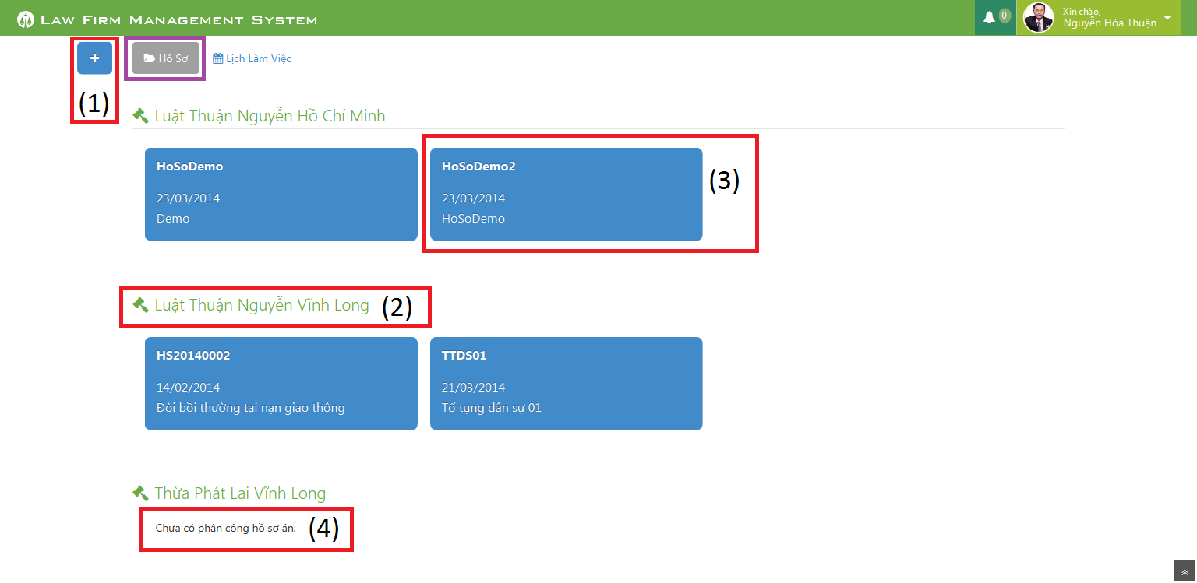

Figure 212: Home Screen Image

#### Home Description

|  |  |  |  |  |  |
| --- | --- | --- | --- | --- | --- |
| No | Name | Type | | | Description |
| 1 | Plus | | Button | Click to show popup for add new case | |
| 2 | Office name | | Label | Show name of office the staff work in | |
| 3 | Case information | | Button | Show important information of the case, click and redirect to view case detail page | |
| 4 | “Chưa có phân công hồ sơ án” | | Label | If the office have no “Đang thụ lý” case, message will be show | |

### User Control Panel

#### Notify Event

##### Notify Event Screen Image

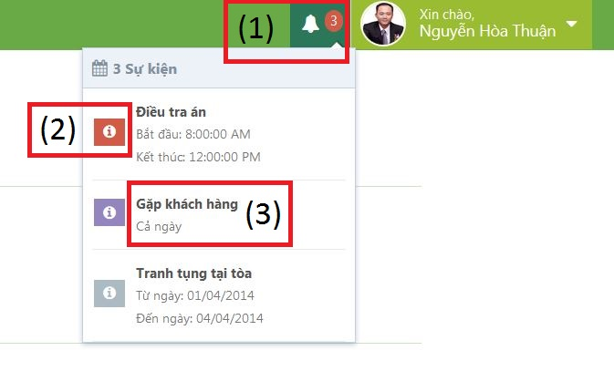

Figure 213: Notify Event Screen Image

##### Notify Event Panel Description

|  |  |  |  |  |  |
| --- | --- | --- | --- | --- | --- |
| No | Name | | Type | | Description |
| 1 | Event count | Label | | Event quantity in “today” need to do. If there is at least 1 event, ring the bell | |
| 2 | Priority | Icon | | Show priority of event | |
| 3 | Title | Label | | Show title and time range of event | |

#### Dropdown Control

##### Dropdown Control Screen Image

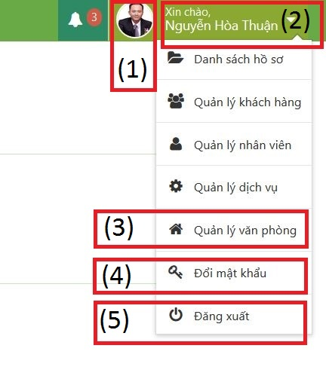

Figure 214: Dropdown Control Screen Image

##### Dropdown Control Description

|  |  |  |  |  |  |
| --- | --- | --- | --- | --- | --- |
| No | Name | | Type | | Description |
| 1 | Avatar | Image | | View avatar of staff | |
| 2 | Staff fullname | Label | | View fullname of staff | |
| 3 | Link to manage | Link | | Click on link and then redirect to manage page | |
| 4 | Link to change password | Link | | Click on link to show modal popup for change password | |
| 5 | Logout | Link | | Click on link to logout of system | |

### Calendar Event

#### Personal Calendar

##### Personal Calendar Screen Image

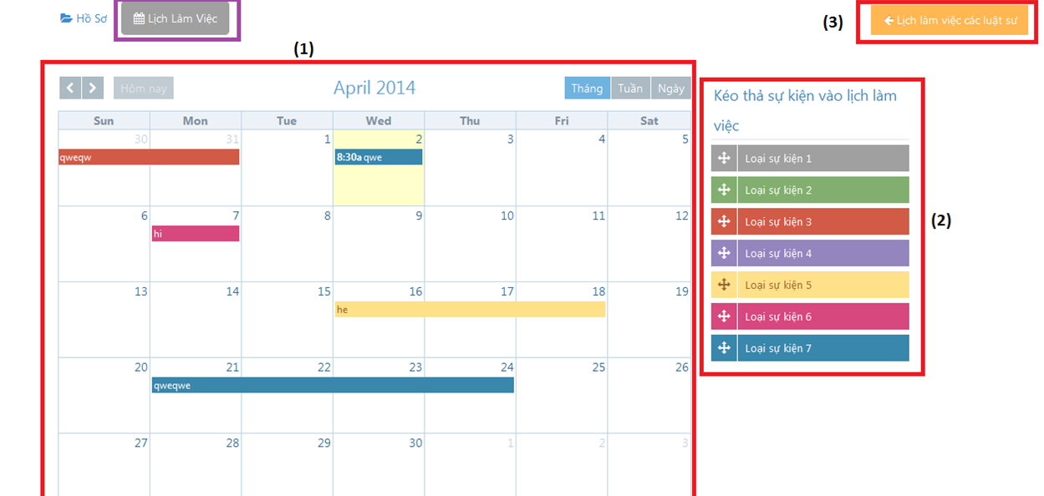

Figure 215: Personal Calendar Screen Image

##### Personal Calendar Description

|  |  |  |  |
| --- | --- | --- | --- |
| No | Name | Type | Description |
| 1 | Calendar | Full Calendar | Show all event of Staff on calendar |
| 2 | Dropable event | Object | Drag and drop into calendar to create new event |
| 3 | Lịch làm việc của các luật sư | Button | Show other staff calendar pop-up |

#### Shared Calendar

##### Shared Calendar Screen Image

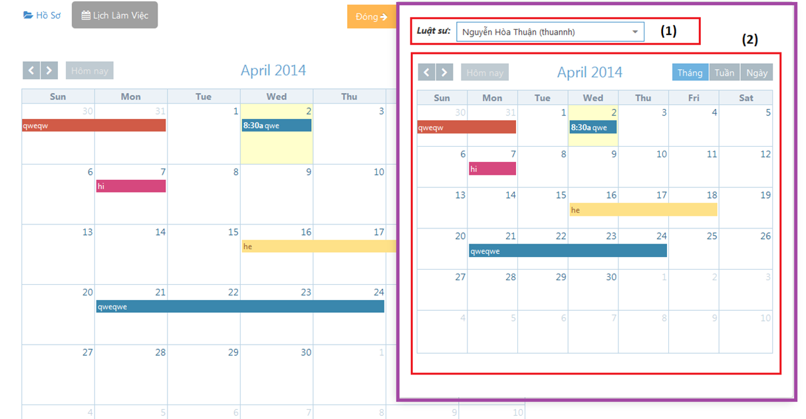

Figure 216: Shared Calendar Screen Image

##### Shared Calendar Description

|  |  |  |  |
| --- | --- | --- | --- |
| No | Name | Type | Description |
| 1 | Luật sư | Search combo-box | Staff name |
| 2 | Calendar | Full calendar | Other staff calendar event |

### Case

#### All Cases

##### All Cases Screen Image

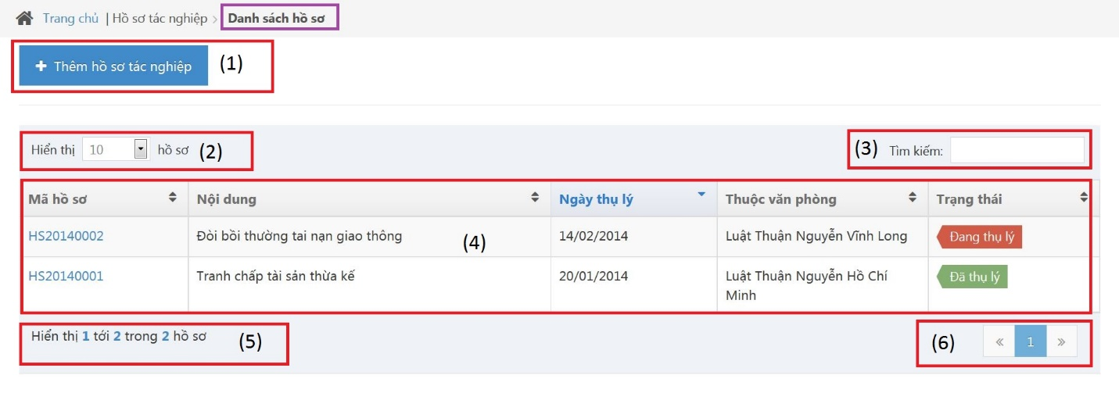

Figure 217: All Cases Screen Image

##### All Cases Description

|  |  |  |  |  |  |
| --- | --- | --- | --- | --- | --- |
| No | Name | | Type | | Description |
| 1 | “Thêm hồ sơ tác nghiệp” | Button | | Click to show popup for add new case | |
| 2 | Line count | Dropdown list | | Select line quantity in table | |
| 3 | “Tìm kiếm” | Textbox | | Search case automatically | |
| 4 | View all cases | Table | | Show all of case | |
| 5 | Case count | Label | | Show case quantity of page in table | |
| 6 | Paging | Button | | List case page by page | |

#### Add New Case

##### Add New Case Screen Image

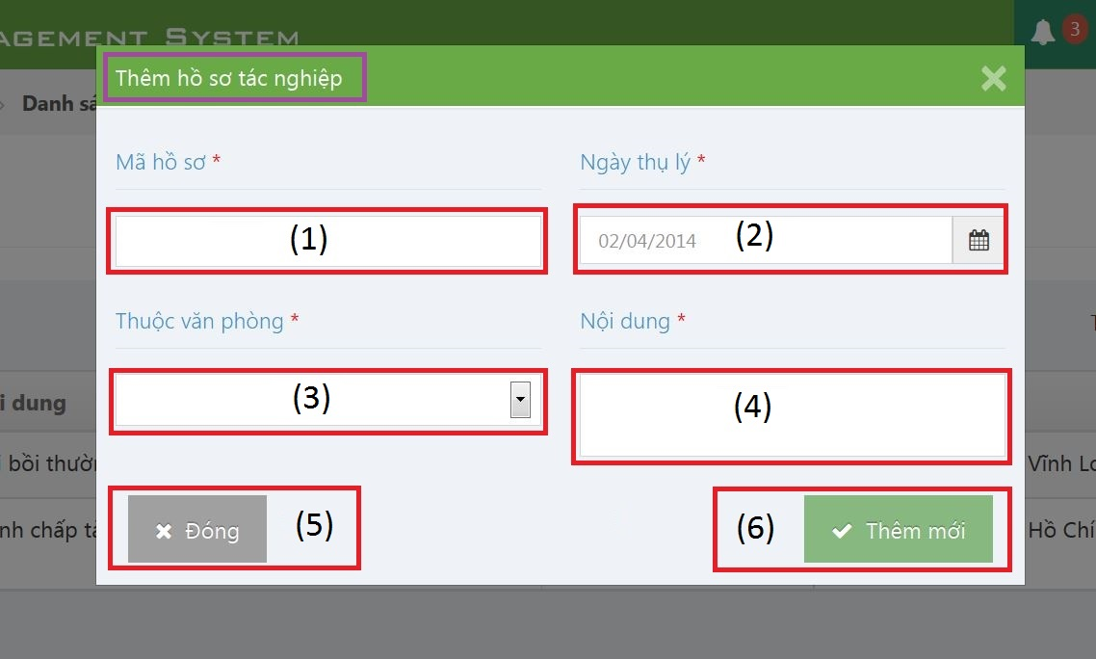

Figure 218: Add New Case Screen Image

##### Add New Case Description

|  |  |  |  |  |  |
| --- | --- | --- | --- | --- | --- |
| No | Name | | Type | | Description |
| 1 | “Mã hồ sơ” | Textbox | | Case code | |
| 2 | “Ngày thụ lý” | Textbox | | Receipt date | |
| 3 | “Thuộc văn phòng” | Textbox | | Choose one office | |
| 4 | “Nội dung” | Textbox | | Case content | |
| 5 | “Đóng” | Button | | Click to close modal popup | |
| 6 | “Thêm mới” | Button | | Click to create a new case | |

#### Case Detail

##### Case Info

###### Case Info Screen Image

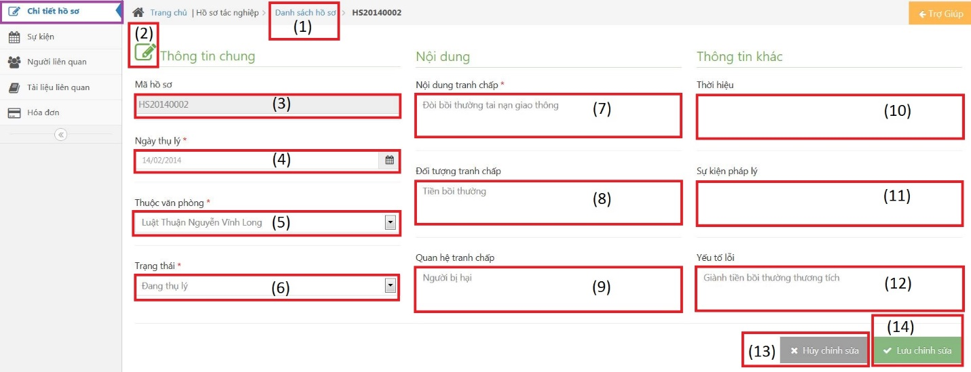

Figure 219: Case Info Screen Image

###### Case Info Description

|  |  |  |  |  |  |
| --- | --- | --- | --- | --- | --- |
| No | Name | | Type | | Description |
| 1 | “Danh sách hồ sơ” | Link | | Redirect to view all cases | |
| 2 | Edit | Button | | Must be click to edit infor | |
| 3 | “Mã hồ sơ” | Textbox | | Case code | |
| 4 | “Ngày thụ lý” | Textbox | | Receipt date | |
| 5 | “Thuộc văn phòng” | Textbox | | Choose one office | |
| 6 | “Trạng thái” | Textbox | | Case status | |
| 7 | “Nội dung tranh chấp” | Textbox | | The contents of dispute | |
| 8 | “Đối tượng tranh chấp” | Textbox | | The subject of dispute | |
| 9 | “Quan hệ tranh chấp” | Textbox | | The relation of dispute | |
| 10 | “Thời hiệu” | Textbox | | The statute of limitations | |
| 11 | “Sự kiện pháp lý” | Textbox | | Legal event | |
| 12 | “Yếu tố lỗi” | Textbox | | Error factor | |
| 13 | “Hủy chỉnh sửa” | Button | | Cancel edit infor | |
| 14 | “Lưu chỉnh sửa” | Button | | Save new infor | |

##### Operation Event

###### Operation Event Screen Image

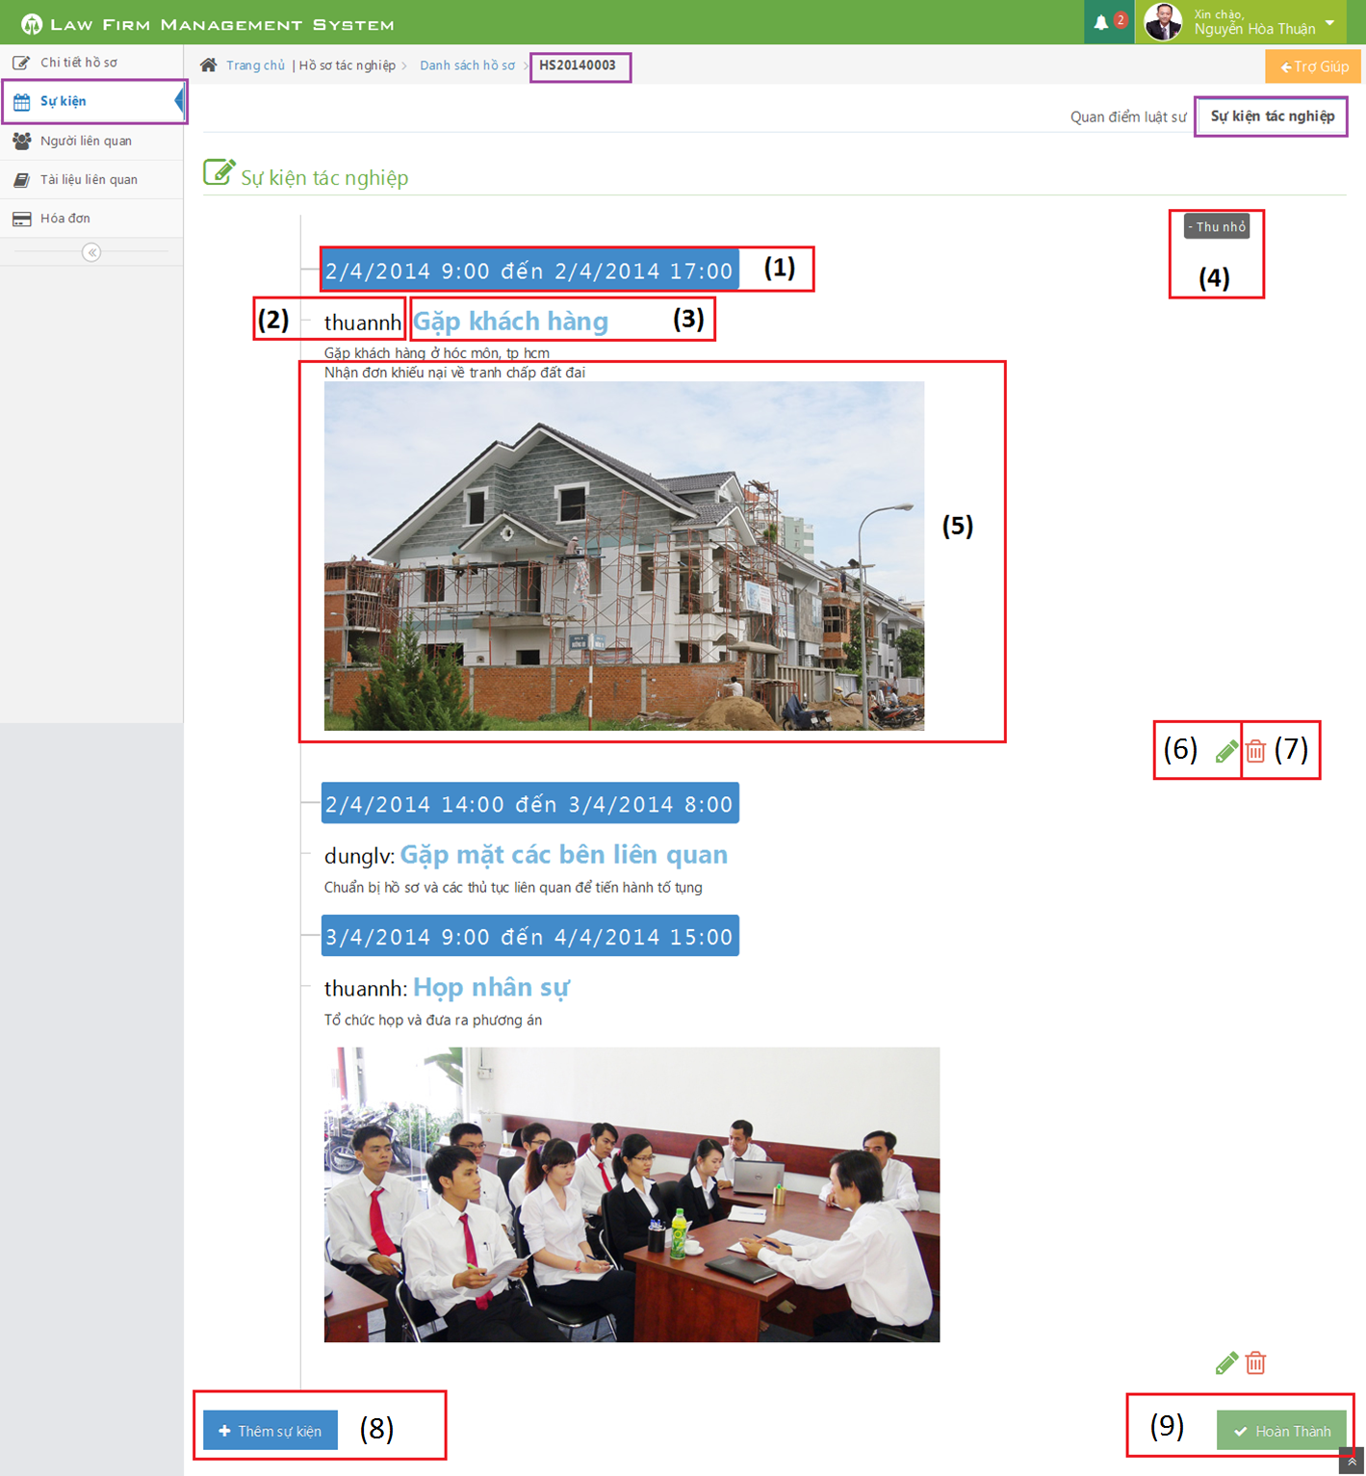

Figure 220: Operation Event Screen Image

###### Operation Event Description

|  |  |  |  |  |  |
| --- | --- | --- | --- | --- | --- |
| No | Name | | Type | | Description |
| 1 | Time range | Label | | Click to choose begin time and end time of event | |
| 2 | Staff username | Label | | The lawyer who create a case | |
| 3 | Title | Label | | Title of Operation Event | |
| 4 | Thu nhỏ / Mở rộng | Button | | Reduce / Expand | |
| 5 | Content | Information | | Content of Operation Event | |
| 6 | Pencil | Button | | Edit operation event | |
| 7 | Trash | Button | | Delete operation event | |
| 8 | Thêm sự kiện | Button | | Click to add new operation event | |
| 9 | Hoàn thành | Button | | Click to finish edit operation event | |

##### Lawyer Related

###### Lawyer Related Screen Image

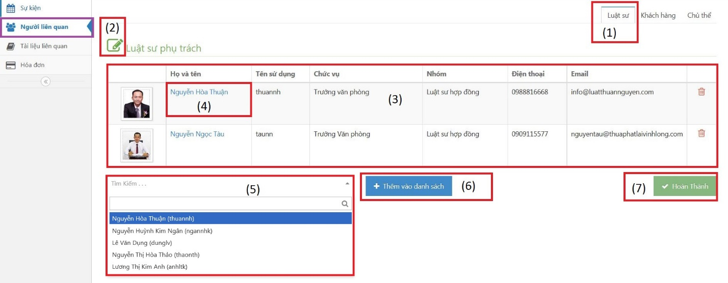

Figure 221: Lawyer Related Screen Image

###### Lawyer Related Description

|  |  |  |  |  |  |
| --- | --- | --- | --- | --- | --- |
| No | Name | | Type | | Description |
| 1 | “Luật sư” | Button | | Change to “Luật sư” tab | |
| 2 | Edit | Button | | Must be click to edit infor | |
| 3 | View all lawyers | Table | | Show all lawyers | |
| 4 | Fullname | Link | | Click to show detail of lawyer | |
| 5 | “Tìm kiếm” | Combo box | | Search lawyer before assign | |
| 6 | “Thêm vào danh sách” | Button | | Click to assign lawyer to current case | |
| 7 | “Hoàn thành” | Button | | Complete assign | |

##### Customer Related

###### Customer Related Screen Image

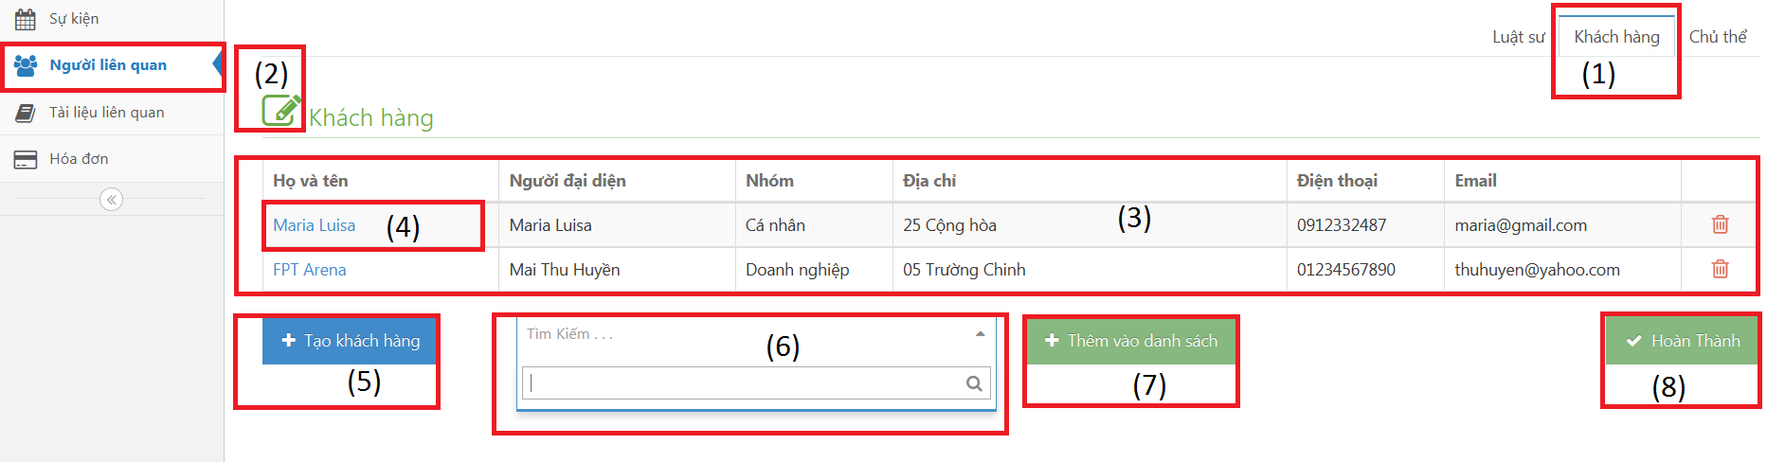

Figure 222: Customer Related Screen Image

###### Customer Related Description

|  |  |  |  |  |  |
| --- | --- | --- | --- | --- | --- |
| No | Name | | Type | | Description |
| 1 | “Khách hàng” | Button | | Change to “Khách hàng” tab | |
| 2 | Edit | Button | | Must be click to edit infor | |
| 3 | View all customers | Table | | Show all customers | |
| 4 | Fullname | Link | | Click to show detail of customer | |
| 5 | “Tạo khách hàng” | Button | | Open popup and then create customer | |
| 6 | “Tìm kiếm” | Combo box | | Search customer before add into case | |
| 7 | “Thêm vào danh sách” | Button | | Click to add lawyer into current case | |
| 8 | “Hoàn thành” | Button | | Complete add | |

##### Subject Related

###### Subject Related Screen Image

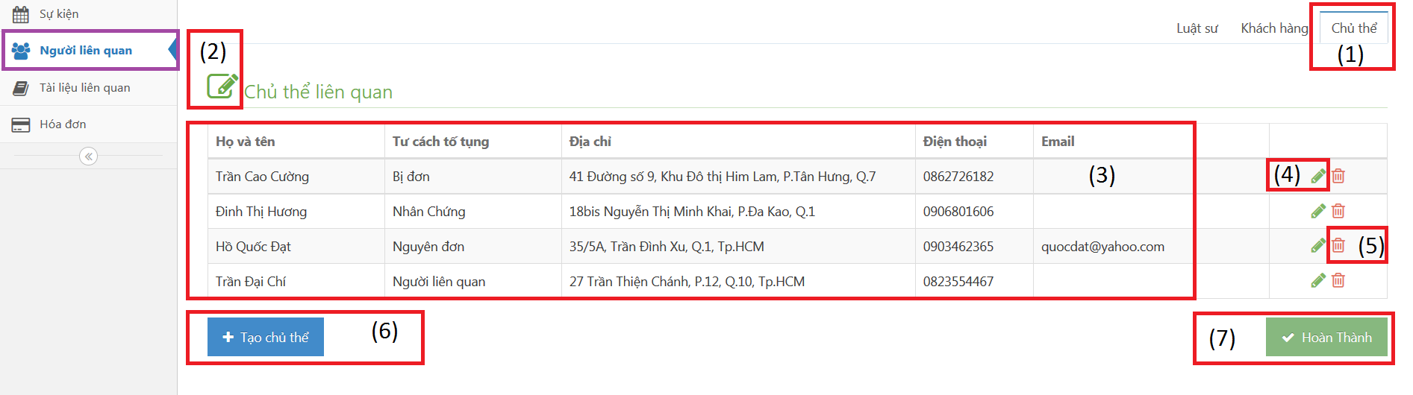

Figure 223: Subject Related Screen Image

###### Subject Related Description

|  |  |  |  |  |  |
| --- | --- | --- | --- | --- | --- |
| No | Name | | Type | | Description |
| 1 | “Chủ thể” | Button | | Change to “Chủ thể” tab | |
| 2 | Edit | Button | | Must be click to edit infor | |
| 3 | View all subjects | Table | | Show all subjects | |
| 4 | Pencil | Button | | Open popup and then edit subject | |
| 5 | Trash | Button | | Delete subject | |
| 6 | “Tạo chủ thể” | Button | | Open popup and then create subject | |
| 7 | “Hoàn thành” | Button | | Complete add | |

##### Document Related

###### Document Related Screen Image

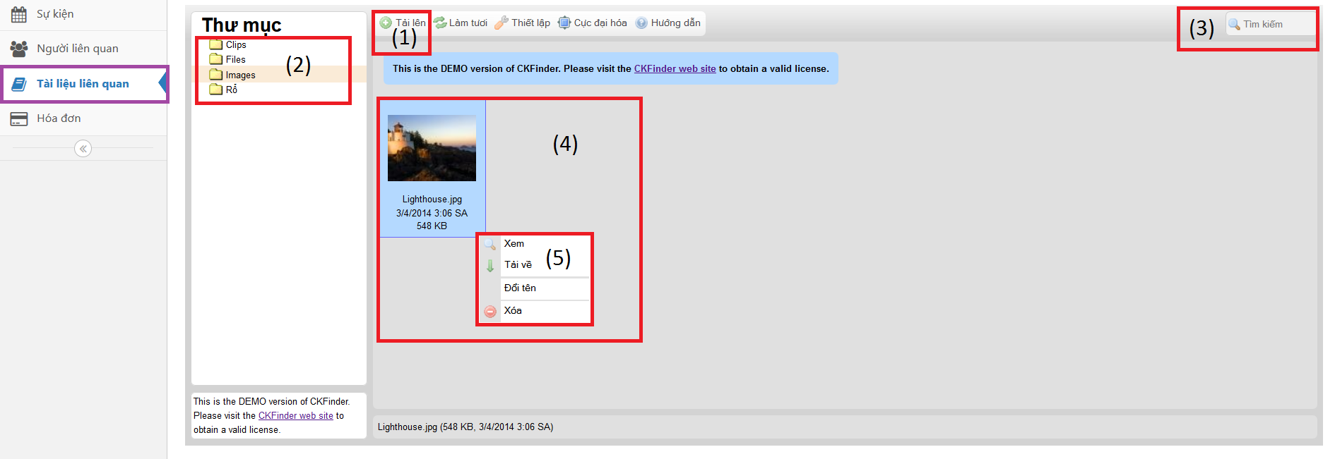

Figure 224: Document Related Screen Image

###### Document Related Description

|  |  |  |  |  |  |
| --- | --- | --- | --- | --- | --- |
| No | Name | | Type | | Description |
| 1 | “Tải lên” | Button | | Upload one or many file to server | |
| 2 | Folder | Button list | | Each folder only allow upload a few type of file | |
| 3 | “Tìm kiếm” | Textbox | | Search file name automatically | |
| 4 | File detail | Information | | Show main information of file | |
| 5 | Properties | Button list | | Allow to View, Dowload, Rename and Delete a file | |

##### Used Service / Payment

###### All Used Services / Payments Screen Image

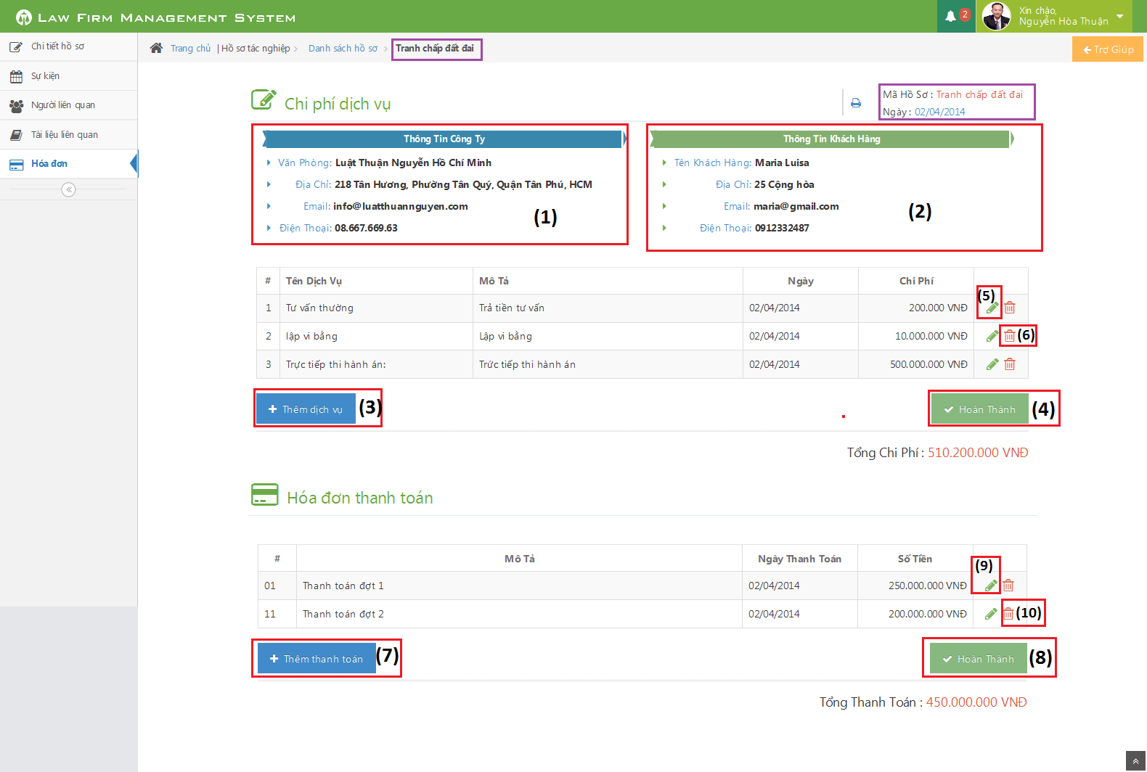

Figure 225: All Used Services / Payments Screen Image

###### All Used Services / Payments Description

|  |  |  |  |  |  |
| --- | --- | --- | --- | --- | --- |
| No | Name | Type | | | Description |
| 1 | List office detail of curent case | | Table | List detail of office in curent case | |
| 2 | List customer detail of curent case | | Table | List detail of customer in curent case | |
| 3 | Thêm dịch vụ | | Button | Click to show popup for add new Used Service | |
| 4 | Hoàn thành | | Button | Click to close table and finish add/edit Used Service | |
| 5 | Edit | | Button | Click to show popup edit detail of Used Service | |
| 6 | Delete | | Button | Click to show popup confirm delete Used Service | |
| 7 | Thêm thanh toán | | Button | Click to show popup for add new Payment | |
| 8 | Hoàn thành | | Button | Click to close table and finish add/edit Payment | |
| 9 | Edit | | Button | Click to show popup edit detail of Payment | |
| 10 | Delete | | Button | Click to show popup confirm delete Payment | |

##### Thư Viện Pháp Luật

###### Thư Viện Pháp Luật Screen Image

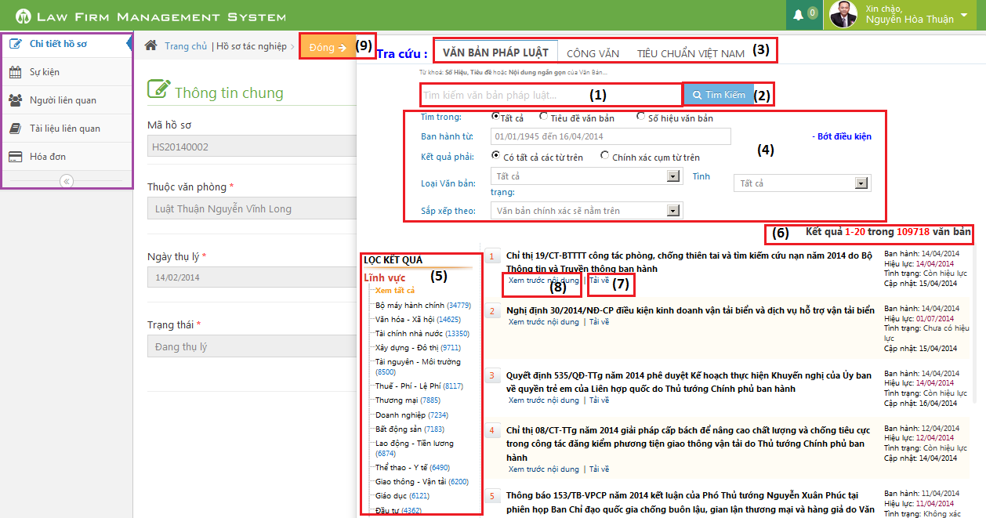

Figure 226: Thư Viện Pháp Luật Screen Image

###### Thư Viện Pháp Luật Description

|  |  |  |  |
| --- | --- | --- | --- |
| No | Name | Type | Description |
| 1 | Input keyword to search | Text box | Input key to search document |
| 2 | Tìm kiếm | Button | Press to search document |
| 3 | Type search of document | Button | Three type of search document |
| 4 | Choose or input other condition of search | Lable | Choose or input to add other condition of search |
| 5 | Choose a link to search other type of document | Lable | Choose a link to search other type of document |
| 6 | Result of search | Lable | Result of search |
| 7 | Download | Button | Click to download document to curent Case |
| 8 | View | Button | Click to view detail of document |
| 9 | Close | Button | Close Search Popup |

### Customer

#### All Customers

##### All Customers Screen Image

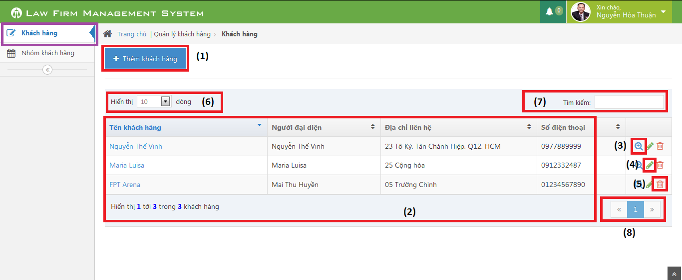

Figure 227: All Customers Screen Image

##### All Customers Description

|  |  |  |  |
| --- | --- | --- | --- |
| No | Name | Type | Description |
| 1 | Thêm khách hàng | Button | Show Add new customer pop-up |
| 2 | Customer table | Table | List Customer |
| 3 | View customer detail | Icon | Show Customer detail pop-up |
| 4 | Edit customer | Icon | Show edit customer pop-up |
| 5 | Delete customer | Icon | Delete customer |
| 6 | Number of rows | Combo-box | Choose number of rows in table |
| 7 | Search | Textbox | Search customer |
| 8 | Paging | Button | Paging the customer list |

#### Customer Detail

##### Customer Detail Screen Image

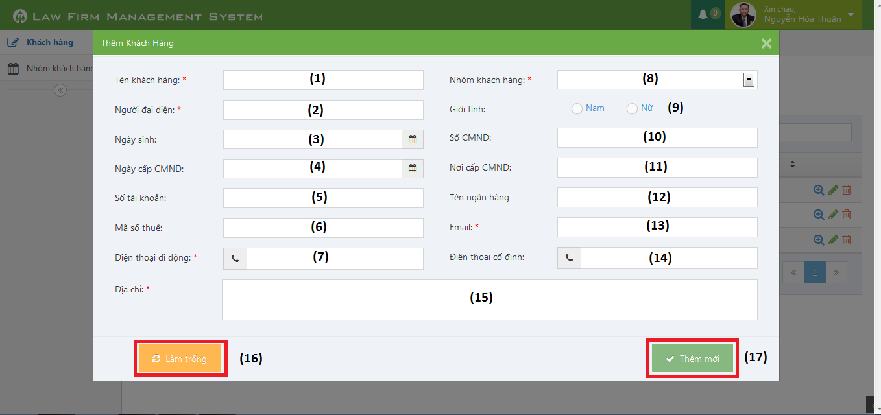

Figure 228: Customer Detail Screen Image

##### Customer Detail Description

|  |  |  |  |
| --- | --- | --- | --- |
| No | Name | Type | Description |
| 1 | Tên Khách hàng | Textbox | Customer name |
| 2 | Người đại diện | Textbox | Presentative |
| 3 | Ngày sinh | Date picker | Date of Birth |
| 4 | Ngày cấp CMND | Date picker | Identity Date |
| 5 | Số tài khoản | Textbox | Bank account |
| 6 | Mã số thuế | Textbox | Tax code |
| 7 | Điện thoại di động | Textbox | Mobile |
| 8 | Nhóm khách hàng | Combo-box | Customer group |
| 9 | Giới tính | Radio-button | Gender |
| 10 | Số CMND | Textbox | Identity Number |
| 11 | Nơi cấp CMND | Textbox | Identity Place |
| 12 | Tên ngân hàng | Textbox | Bank Branch |
| 13 | Email | Textbox | Email |
| 14 | Điện thoại cố định | Textbox | Phone |
| 15 | Địa chỉ | Text area | Address |
| 16 | Làm trống | Button | Clear all field |
| 17 | Thêm mới | Button | Add new customer |

### Staff

#### All Staffs

##### All Staffs Screen Image

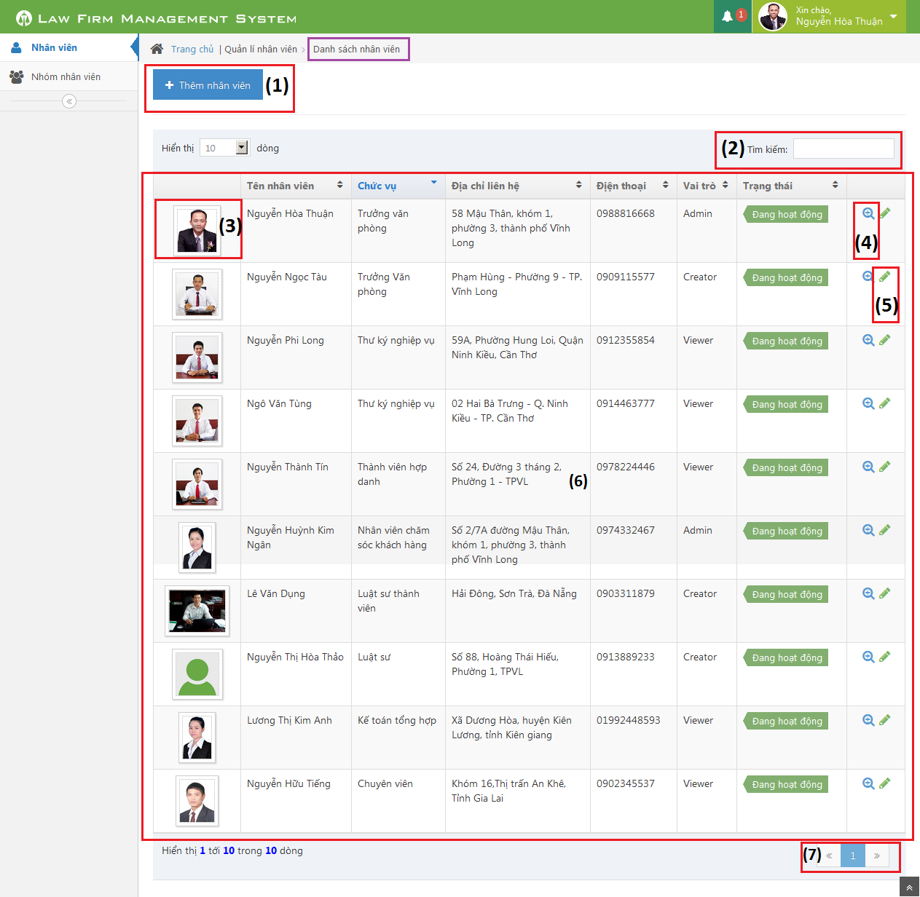

Figure 229: All Staffs Screen Image

##### All Staffs Description

|  |  |  |  |  |  |
| --- | --- | --- | --- | --- | --- |
| No | Name | | Type | | Description |
| 1 | Thêm nhân viên | Button | | Click to show popup for add new staff | |
| 2 | Tìm kiếm | Textbox | | Search staff | |
| 3 | Image of staff | Image | | Click to show popup detail of staff | |
| 4 | View | Button | | Click to show popup detail of staff | |
| 5 | Edit | Button | | Click to show popup edit detail of staff information. | |
| 6 | List all staff | Table | | List all staff | |
| 7 | Paging | Button | | Paging page | |

#### Staff Detail

##### Staff Detail Screen Image

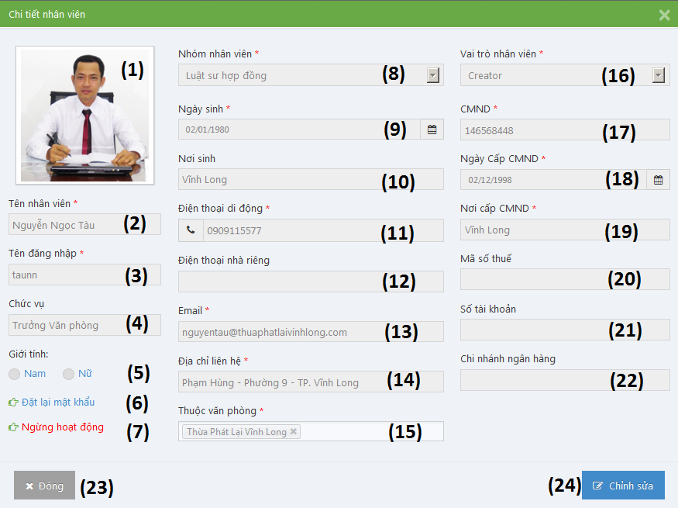

Figure 230: Staff Detail Screen Image

##### Staff Detail Description

|  |  |  |  |
| --- | --- | --- | --- |
| No | Name | Type | Description |
| 1 | Image of staff | Image | Image of staff |
| 2 | Tên nhân viên | Textbox | Name of staff |
| 3 | Tên đăng nhập | Textbox | Username of staff |
| 4 | Chức vụ | Textbox | Position of staff |
| 5 | Giới tính | Radio button | Choose sex of staff |
| 6 | Đặt lại mật khẩu | Link | Reset password of staff to default |
| 7 | Ngừng hoạt động / Hoạt động lại | Link | Change status of staff |
| 8 | Nhóm nhân viên | Textbox | Select group of staff |
| 9 | Ngày sinh | Datetime picker | Date of birth of staff |
| 10 | Nơi sinh | Textbox | Place of birth of staff |
| 11 | Điện thoại di động | Textbox | Phone number of staff |
| 12 | Điện thoại nhà riêng | Textbox | Telephone of staff |
| 13 | Email | Textbox | Email of staff |
| 14 | Địa chỉ liên hệ | Textbox | Address of staff |
| 15 | Thuộc văn phòng | Multiple select box | Select office of staff |
| 16 | Vai trò nhân viên | Select box | Select role of staff |
| 17 | CMND | Textbox | Indentity number of staff |
| 18 | Ngày cấp CMND | Datetime picker | Date of Identity of staff |
| 19 | Nơi cấp CMND | Textbox | Place of Identity of staff |
| 20 | Mã số thuế | Textbox | Tax number of staff |
| 21 | Số tài khoản | Textbox | Bank account number of staff |
| 22 | Chi nhánh ngân hàng | Textbox | Name of bank of staff |
| 23 | Đóng | Button | Close Popup and back to list staff screen. |
| 24 | Lưu chỉnh sửa | Button | Update staff information to database |

### Service

#### All Services

##### All Services Screen Image

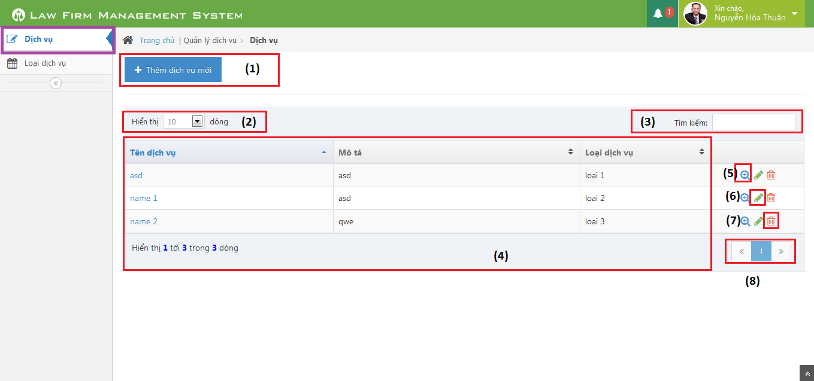

Figure 231: All Services Screen Image

##### All Services Description

|  |  |  |  |
| --- | --- | --- | --- |
| No | Name | Type | Description |
| 1 | Thêm dịch vụ mới | Button | Add new service |
| 2 | Dòng hiển thị | Combo-box | Rows of record in table |
| 3 | Tìm kiếm | Textbox | Search service |
| 4 | List Services | Table | List all services |
| 5 | View customer detail | Icon | Show Customer detail pop-up |
| 6 | Edit customer | Icon | Show edit customer pop-up |
| 7 | Delete customer | Icon | Delete customer |
| 8 | Paging | Button | Paging the customer list |

#### Service Detail

##### Service Detail Screen Image

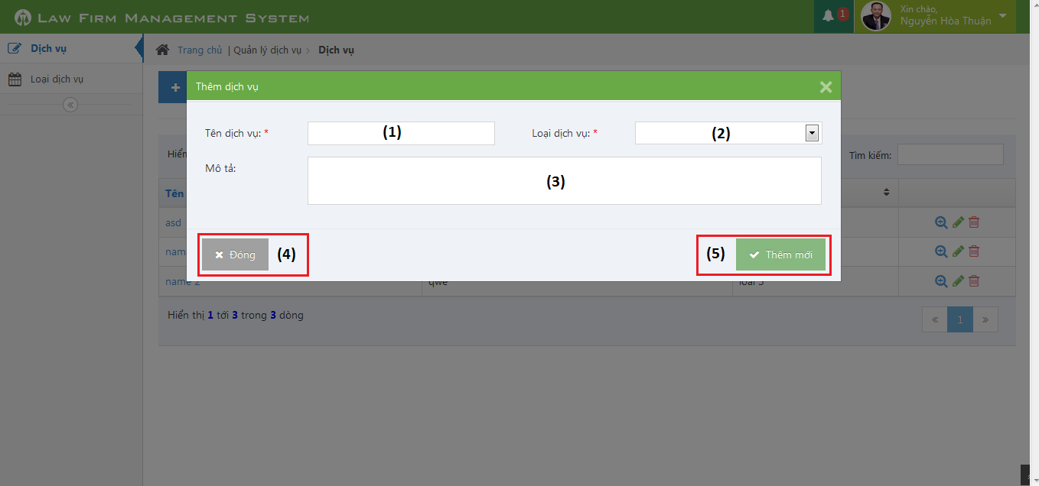

Figure 232: Service Detail Screen Image

##### Service Detail Description

|  |  |  |  |
| --- | --- | --- | --- |
| No | Name | Type | Description |
| 1 | Tên dịch vụ | Textbox | Add new service |
| 2 | Loại dịch vụ | Combo-box | Service type |
| 3 | Mô tả | Text area | Description |
| 4 | Đóng | Button | Close pop-up |
| 5 | Thêm mới | Button | Add new service |

### Office

#### All Offices

##### All Offices Screen Image

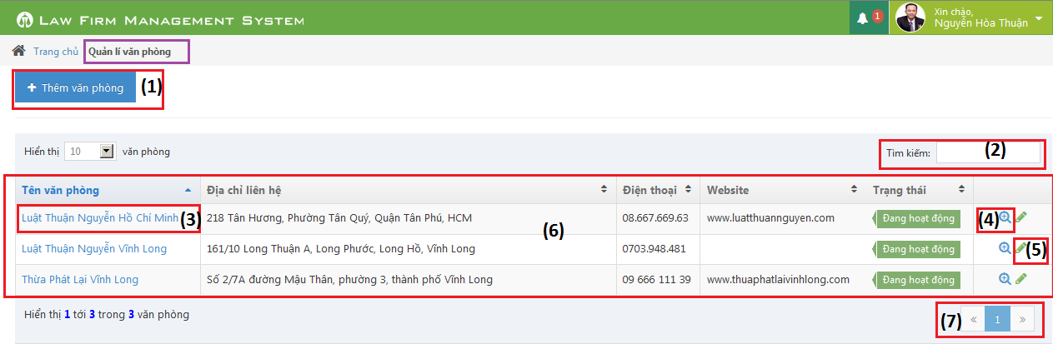

Figure 233: All Offices Screen Image

##### All Offices Description

|  |  |  |  |  |  |
| --- | --- | --- | --- | --- | --- |
| No | Name | | Type | | Description |
| 1 | Thêm văn phòng | Button | | Click to show popup for add new offce | |
| 2 | Tìm kiếm | Textbox | | Search ofice | |
| 3 | Name of office | bable | | Click to show popup detail of office | |
| 4 | View | Button | | Click to show popup detail of office | |
| 5 | Edit | Button | | Click to show popup edit detail of office information. | |
| 6 | List all office | Table | | List all office | |
| 7 | Paging | Button | | Paging page | |

#### Office Detail

##### Office Detail Screen Image

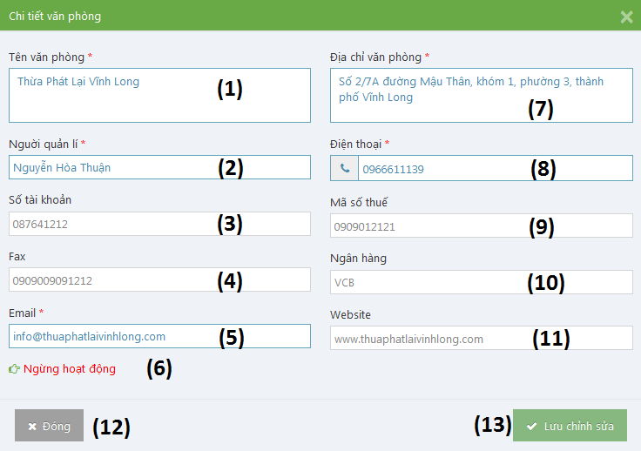

Figure 234: Office Detail Screen Image

##### Office Detail Description

|  |  |  |  |
| --- | --- | --- | --- |
| No | Name | Type | Description |
| 1 | Tên văn phòng | Textbox | Name of office |
| 2 | Người quản lí | Textbox | Nam’s manager of office |
| 3 | Số tài khoản | Textbox | Bank account number of office |
| 4 | Fax | Textbox | Fax of office |
| 5 | Email | Textbox | Email of office |
| 6 | Ngừng hoạt động / Hoạt động lại | Link | Change status of office |
| 7 | Địa chỉ văn phòng | Textbox | Address of office |
| 8 | Điện thoại | Textbox | Phone number of office |
| 9 | Mã số thuế | Textbox | Tax number of office |
| 10 | Số tài khoản | Textbox | Bank account number of office |
| 11 | Ngân hàng | Textbox | Name of bank of office |
| 12 | Đóng | Button | Close Popup and back to list office screen. |
| 13 | Lưu chỉnh sửa | Button | Update office information to database |

### Salary

#### All Salary

##### All Salary Screen Image

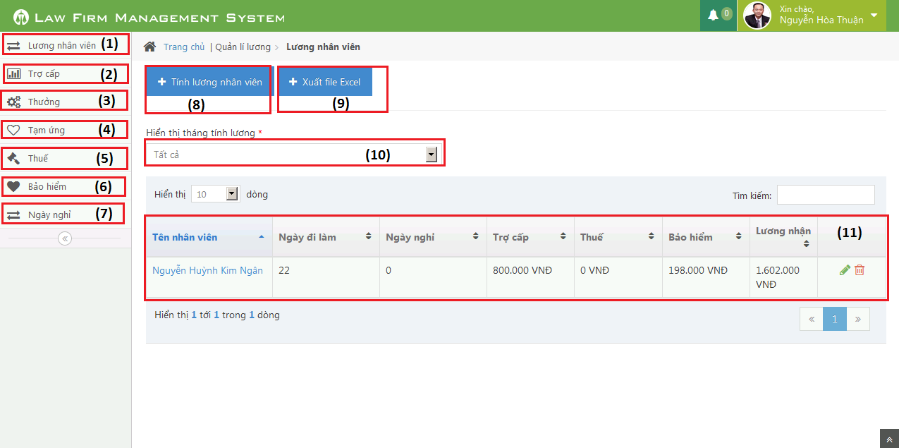

##### All Salary Description

|  |  |  |  |
| --- | --- | --- | --- |
| No | Name | Type | Description |
| 1 | Lương nhân viên | Button | Manager caculator staff’s salary |
| 2 | Trợ cấp | Button | Manager benefit |
| 3 | Thưởng | Button | Manager reward |
| 4 | Tạm ứng | Button | Manager impress |
| 5 | Thuế | Button | Manager tax |
| 6 | Bảo hiểm | Button | Manager assurance |
| 7 | Ngày nghỉ | Button | Manager timesheet |
| 8 | Tính lương nhân viên | Button | Caculator staff’s salary |
| 9 | Xuất file excel | button | Export to excel |
| 10 | Hiển thị lương nhân viên theo tháng | Textbox | Sort staff’s salary by month |
| 11 | Table lương nhân viên | table | Table diplay all staff’s salary |

### Salary Detail

##### Salary Detail Screen Image

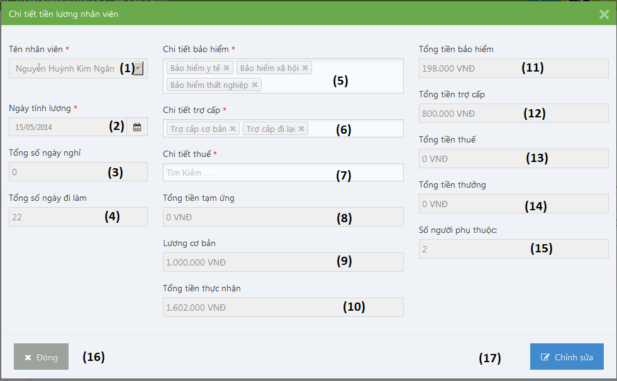

##### Salary Detail Description

|  |  |  |  |
| --- | --- | --- | --- |
| No | Name | Type | Description |
| 1 | Tên nhân viên | Textbox | Name’s staff |
| 2 | Ngày tính lương | Textbox | Date count salay |
| 3 | Tổng số ngày nghỉ | Textbox | Total absent |
| 4 | Tổng số ngày đi làm | Textbox | Total present |
| 5 | Chi tiết bảo hiểm | Textbox | Detail assurance |
| 6 | Chi tiết trợ cấp | Textbox | Detail benefit |
| 7 | Chi tiết thuế | Textbox | Detail tax |
| 8 | Tổng tiền tạm ứng | Textbox | Total impress |
| 9 | Lương cơ bản | Textbox | Base salary |
| 10 | Tổng tiền thực nhận | Textbox | Actual money |
| 11 | Tổng tiền bảo hiểm | Textbox | Total assurance |
| 12 | Tổng tiền trợ cấp | Textbox | Total benefit |
| 13 | Tổng tiền thuế | Textbox | Total tax |
| 14 | Tổng tiền thưởng | Textbox | Total rewward |
| 15 | Số người phụ thuộc: | Textbox | Number people |
| 16 | Đóng | Button | Close pop up |
| 17 | Chỉnh sửa | Button | Edit satff salary |

## Database Design

### Relational Database Diagram

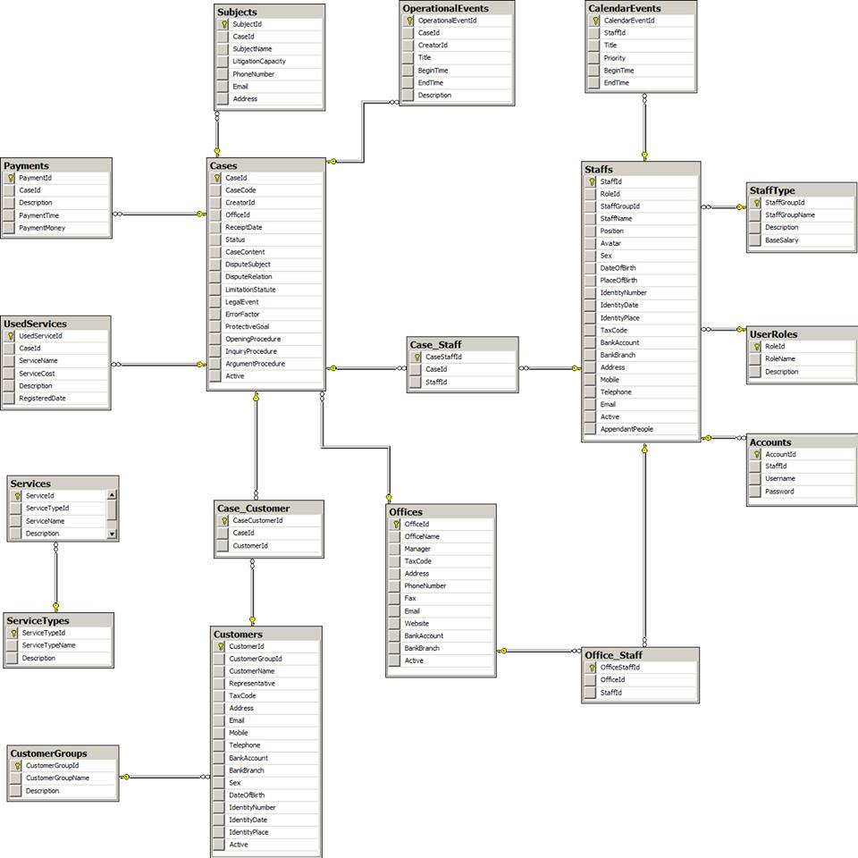

Figure 235: Relational Database Diagram

### Table Dictionary

#### Cases Table

|  |  |  |  |  |
| --- | --- | --- | --- | --- |
| Field Name | Type | Null | P/F Key | Thuật ngữ tiếng Việt |
| CaseId | int |  | PK |  |
| CaseCode | nvarchar(50) |  |  | Mã hồ sơ |
| CreatorId | int |  | FK |  |
| OfficeId | int |  | FK |  |
| ReceiptDate | date |  |  | Ngày thụ lý |
| Status | nvarchar(50) |  |  | Trạng thái hồ sơ |
| CaseContent | nvarchar(MAX) |  |  | Nội dung |
| DisputeSubject | nvarchar(MAX) | x |  | Đối tượng tranh chấp |
| DisputeRelation | nvarchar(MAX) | x |  | Quan hệ tranh chấp |
| LimitationStatute | nvarchar(MAX) | x |  | Thời hiệu |
| LegalEvent | nvarchar(MAX) | x |  | Sự kiện pháp lý |
| ErrorFactor | nvarchar(MAX) | x |  | Yếu tố lỗi |
| ProtectiveGoal | nvarchar(MAX) | x |  | Mục tiêu bảo vệ |
| OpeningProcedure | nvarchar(MAX) | x |  | Phần thủ tục bắt đầu |
| InquiryProcedure | nvarchar(MAX) | x |  | Phần thủ tục xét hỏi |
| ArgumentProcedure | nvarchar(MAX) | x |  | Phần tranh luận |
| Active | bit |  |  |  |

#### OperationEvents Table

|  |  |  |  |  |
| --- | --- | --- | --- | --- |
| Field Name | Type | Null | P/F Key | Thuật ngữ tiếng Việt |
| OperationalEventId | int |  | PK |  |
| CaseId | int |  | FK |  |
| CreatorId | int |  | FK |  |
| Title | nvarchar(100) |  |  | Tiêu đề |
| BeginTime | datetime |  |  | Thời gian bắt đầu |
| EndTime | datetime |  |  | Thời gian kết thúc |
| Description | nvarchar(MAX) | x |  | Mô tả nội dung |

#### Subjects Table

|  |  |  |  |  |
| --- | --- | --- | --- | --- |
| Field Name | Type | Null | P/F Key | Thuật ngữ tiếng Việt |
| SubjectId | int |  | PK |  |
| CaseId | int |  | FK |  |
| SubjectName | nvarchar(50) |  |  | Tên chủ thể |
| LitigationCapacity | nvarchar(50) |  |  | Tư cách tố tụng |
| PhoneNumber | nvarchar(20) | x |  | Số điện thoại |
| Email | nvarchar(50) | x |  | Hòm thư |
| Address | nvarchar(100) | x |  | Địa chỉ |

#### UsedServices Table

|  |  |  |  |  |
| --- | --- | --- | --- | --- |
| Field Name | Type | Null | P/F Key | Thuật ngữ tiếng Việt |
| UsedServiceId | int |  | PK |  |
| CaseId | int |  | FK |  |
| ServiceName | nvarchar(50) |  |  | Tên dịch vụ sử dụng |
| ServiceCost | int |  |  | Chi phí của dịch vụ |
| RegisteredDate | date |  |  | Ngày đăng ký dịch vụ |
| Description | nvarchar(MAX) |  |  | Mô tả chi tiết |

#### Payments Table

|  |  |  |  |  |
| --- | --- | --- | --- | --- |
| Field Name | Type | Null | P/F Key | Thuật ngữ tiếng Việt |
| PaymentId | int |  | PK |  |
| CaseId | int |  | FK |  |
| Description | nvarchar(MAX) |  |  | Mô tả chi tiết |
| PaymentTime | datetime |  |  | Thời gian thanh toán |
| PaymentMoney | int |  |  | Số tiền thanh toán |

#### Staffs Table

|  |  |  |  |  |
| --- | --- | --- | --- | --- |
| Field Name | Type | Null | P/F Key | Thuật ngữ tiếng Việt |
| StaffId | int |  | PK |  |
| StaffGroupId | int |  | FK |  |
| StaffName | nvarchar(50) |  |  | Tên nhân viên |
| Position | nvarchar(50) | x |  | Chức vụ |
| Avatar | nvarchar(100) | x |  | Đường dẫn ảnh đại diện |
| Sex | nvarchar(30) | x |  | Giới tính |
| DateOfBirth | date |  |  | Ngày sinh |
| PlaceOfBirth | nvarchar(100) | x |  | Nơi sinh |
| IdentityNumber | nvarchar(12) |  |  | Số CMND |
| IdentityDate | date |  |  | Ngày cấp |
| IdentityPlace | nvarchar(50) |  |  | Nơi cấp |
| TaxCode | nvarchar(14) | x |  | Mã số thuế |
| BankAccount | nvarchar(20) | x |  | Số TK ngân hàng |
| BankBranch | nvarchar(50) | x |  | Chi nhánh ngân hàng |
| Address | nvarchar(100) |  |  | Địa chỉ |
| Mobile | nvarchar(20) |  |  | Số di động |
| Telephone | nvarchar(20) | x |  | Số máy bàn |
| Email | nvarchar(50) |  |  | Hòm thư |
| Active  AppendantPeople | bit  int | x |  | Người phụ thuộc |

#### StaffType Table

|  |  |  |  |  |
| --- | --- | --- | --- | --- |
| Field Name | Type | Null | P/F Key | Thuật ngữ tiếng Việt |
| StaffGroupId | int |  | PK |  |
| StaffGroupName | nvarchar(50) |  |  | Tên nhóm nhân viên |
| Description  BaseSalary | nvarchar(MAX)  float | x  x |  | Mô tả chi tiết  Lương cơ bản |

#### UserRoles Table

|  |  |  |  |  |
| --- | --- | --- | --- | --- |
| Field Name | Type | Null | P/F Key | Thuật ngữ tiếng Việt |
| RoleId | int |  | PK |  |
| RoleName | nvarchar(50) |  |  | Tên vai trò |
| Description | nvarchar(MAX) | x |  | Mô tả chi tiết |

#### Accounts Table

|  |  |  |  |  |
| --- | --- | --- | --- | --- |
| Field Name | Type | Null | P/F Key | Thuật ngữ tiếng Việt |
| AccountId | int |  | PK |  |
| StaffId | int |  | FK |  |
| RoleId | int |  | FK |  |
| Username | nvarchar(50) |  |  | Tên đăng nhập |
| Password | nvarchar(50) |  |  | Mật khẩu |

#### CalendarEvents Table

|  |  |  |  |  |
| --- | --- | --- | --- | --- |
| Field Name | Type | Null | P/F Key | Thuật ngữ tiếng Việt |
| CalendarEventId | int |  | PK |  |
| StaffId | int |  | FK |  |
| Title | nvarchar(100) |  |  | Tiêu đề |
| Priority | nvarchar(50) |  |  | Mức độ ưu tiên |
| BeginTime | datetime |  |  | Thời gian bắt đầu |
| EndTime | datetime |  |  | Thời gian kết thúc |

#### Customers Table

|  |  |  |  |  |
| --- | --- | --- | --- | --- |
| Field Name | Type | Null | P/F Key | Thuật ngữ tiếng Việt |
| CustomerId | int |  | PK |  |
| CustomerGroupId | int |  | FK |  |
| CustomerName | nvarchar(50) |  |  | Tên khách hàng |
| Representative | nvarchar(50) | x |  | Người đại diện |
| TaxCode | nvarchar(14) | x |  | Mã số thuế |
| Address | nvarchar(100) |  |  | Địa chỉ |
| Email | nvarchar(50) |  |  | Hòm thư |
| Mobile | nvarchar(20) |  |  | Số di động |
| Telephone | nvarchar(20) | x |  | Số máy bàn |
| BankAccount | nvarchar(20) | x |  | Số TK ngân hàng |
| BankBranch | nvarchar(50) | x |  | Chi nhánh ngân hàng |
| Sex | nvarchar(20) | x |  | Giới tính |
| DateOfBirth | date | x |  | Ngày sinh |
| IdentityNumber | nvarchar(12) | x |  | Số CMND |
| IdentityDate | date | x |  | Ngày cấp |
| IdentityPlace | nvarchar(50) | x |  | Nơi cấp |
| Active | bit |  |  |  |

#### CustomerGroups Table

|  |  |  |  |  |
| --- | --- | --- | --- | --- |
| Field Name | Type | Null | P/F Key | Thuật ngữ tiếng Việt |
| CustomerGroupId | int |  | PK |  |
| CustomerGroupName | nvarchar(50) |  |  | Tên nhóm khách hàng |
| Description | nvarchar(MAX) | x |  | Mô tả chi tiết |

#### Offices Table

|  |  |  |  |  |
| --- | --- | --- | --- | --- |
| Field Name | Type | Null | P/F Key | Thuật ngữ tiếng Việt |
| OfficeId | int |  | PK |  |
| OfficeName | nvarchar(100) |  |  | Tên văn phòng |
| Manager | nvarchar(50) |  |  | Quản lý |
| TaxCode | nvarchar(14) | x |  | Mã số thuế |
| Address | nvarchar(100) |  |  | Địa chỉ |
| PhoneNumber | nvarchar(20) |  |  | Số điện thoại |
| Fax | nvarchar(20) | x |  | Số Fax |
| Email | nvarchar(50) |  |  | Hòm thư |
| Website | nvarchar(50) | x |  | Địa chỉ web |
| BankAccount | nvarchar(20) | x |  | Số TK ngân hàng |
| BankBranch | nvarchar(50) | x |  | Chi nhánh ngân hàng |
| Active | bit |  |  |  |

#### Services Table

|  |  |  |  |  |
| --- | --- | --- | --- | --- |
| Field Name | Type | Null | P/F Key | Thuật ngữ tiếng Việt |
| ServiceId | int |  | PK |  |
| ServiceTypeId | int |  | FK |  |
| ServiceName | nvarchar(50) |  |  | Tên dịch vụ |
| Description | nvarchar(MAX) | x |  | Mô tả chi tiết |

#### ServiceTypes Table

|  |  |  |  |  |
| --- | --- | --- | --- | --- |
| Field Name | Type | Null | P/F Key | Thuật ngữ tiếng Việt |
| ServiceTypeId | int |  | PK |  |
| ServiceTypeName | nvarchar(50) |  |  | Tên loại dịch vụ |
| Description | nvarchar(MAX) | x |  | Mô tả chi tiết |